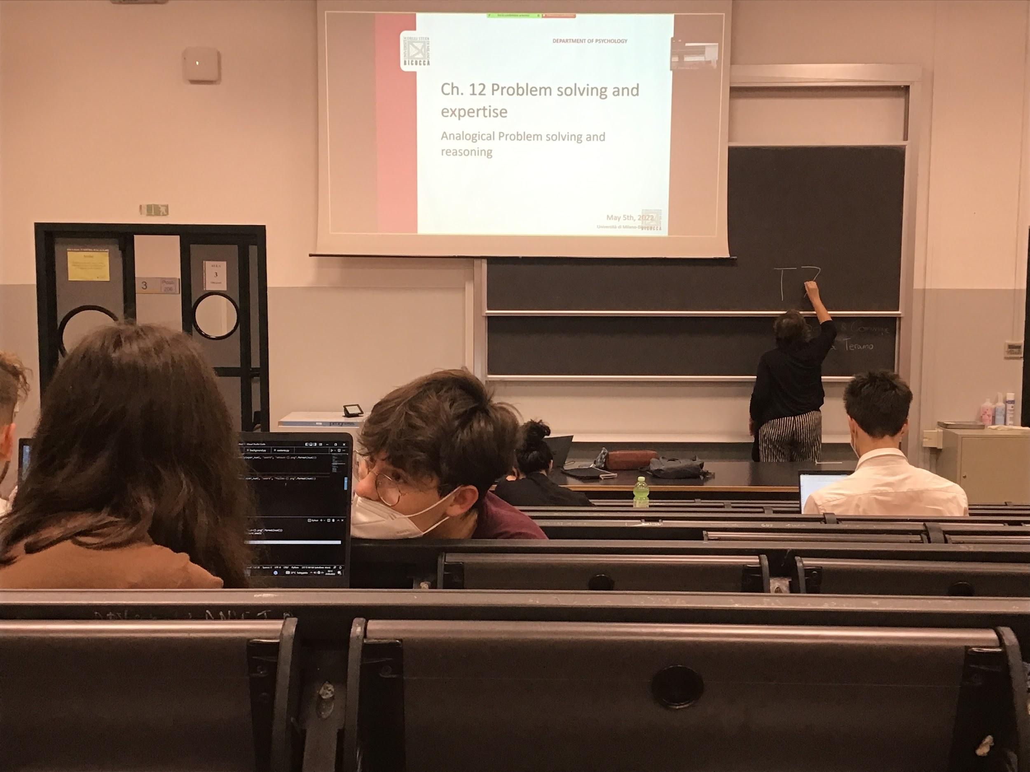

Analogical problem solving

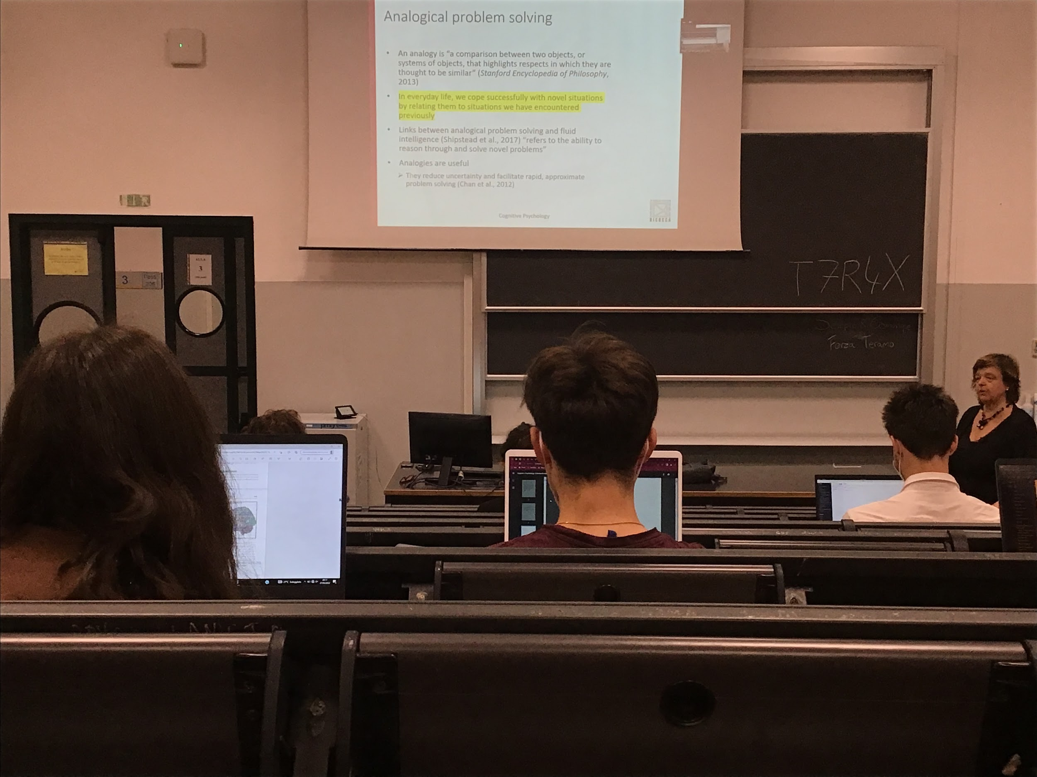

Analogies help a lot in our everyday life. Compare different situations and help us solve problems that we face daily

Relate what is happening now to something happened earlier

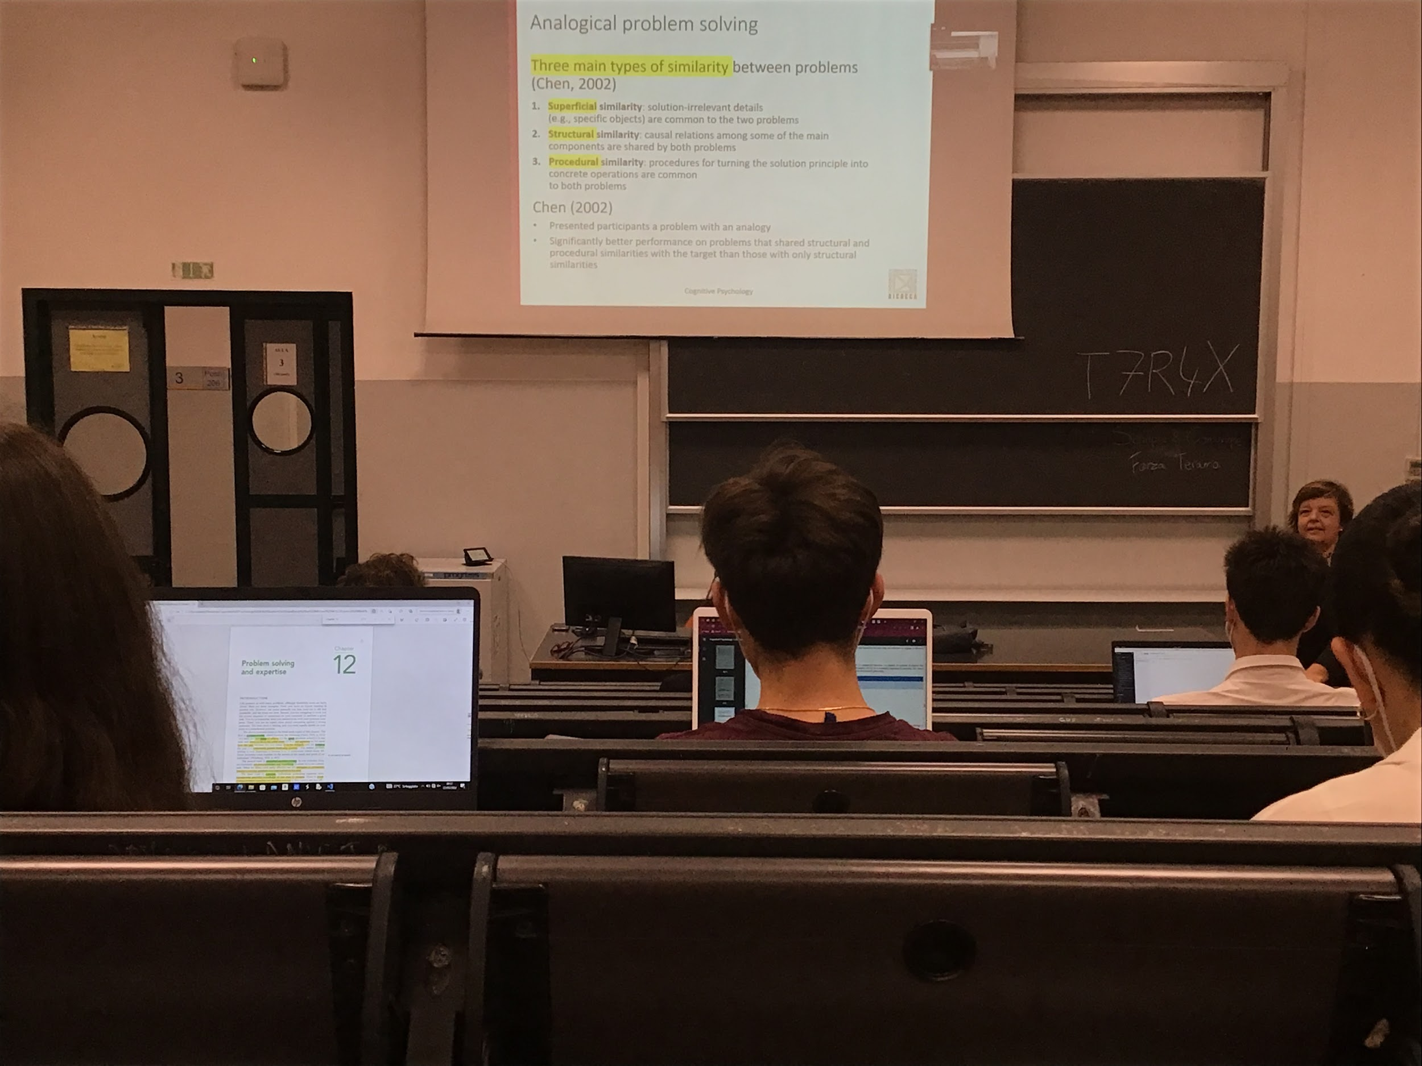

3 main types of similarly (analogies that we can use)

* **Superficial similarity**: some objects are the same is the easiest that comes to mind but not very helpful
* **Structural similarity**: contains same type of relations between components
* **Procedural similarity**: use the same procedure to solve the other problem

Analogies can help us improve our performance

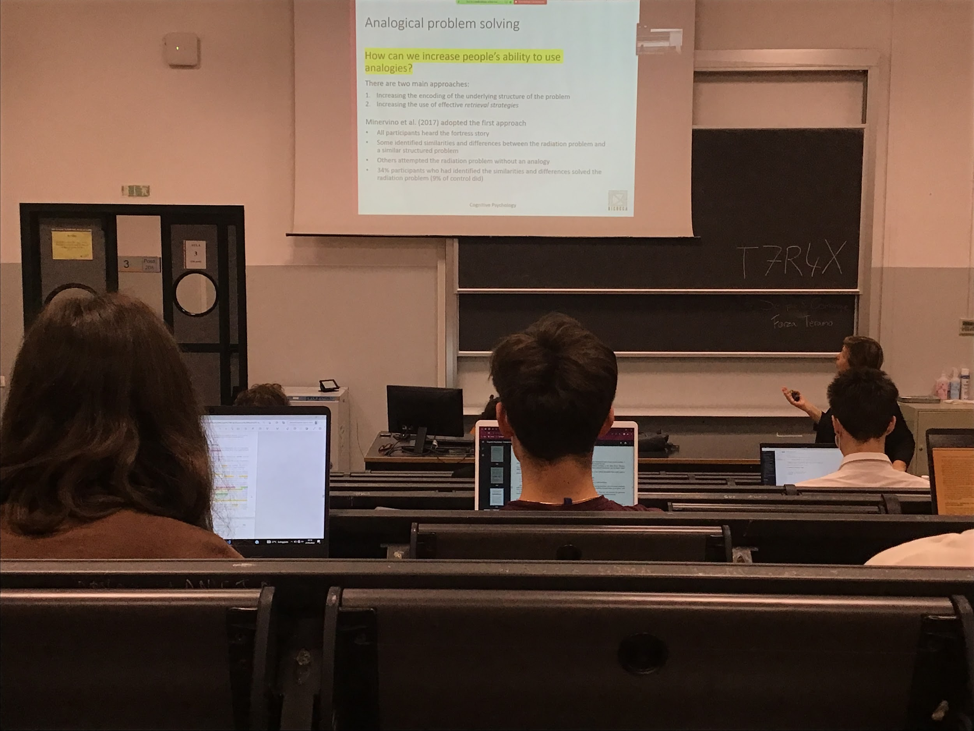

How can we increase people ability to use analogies

Understanding what the problem is can help you extend your ability to solve it

Also being able to retrieve from memory previous information

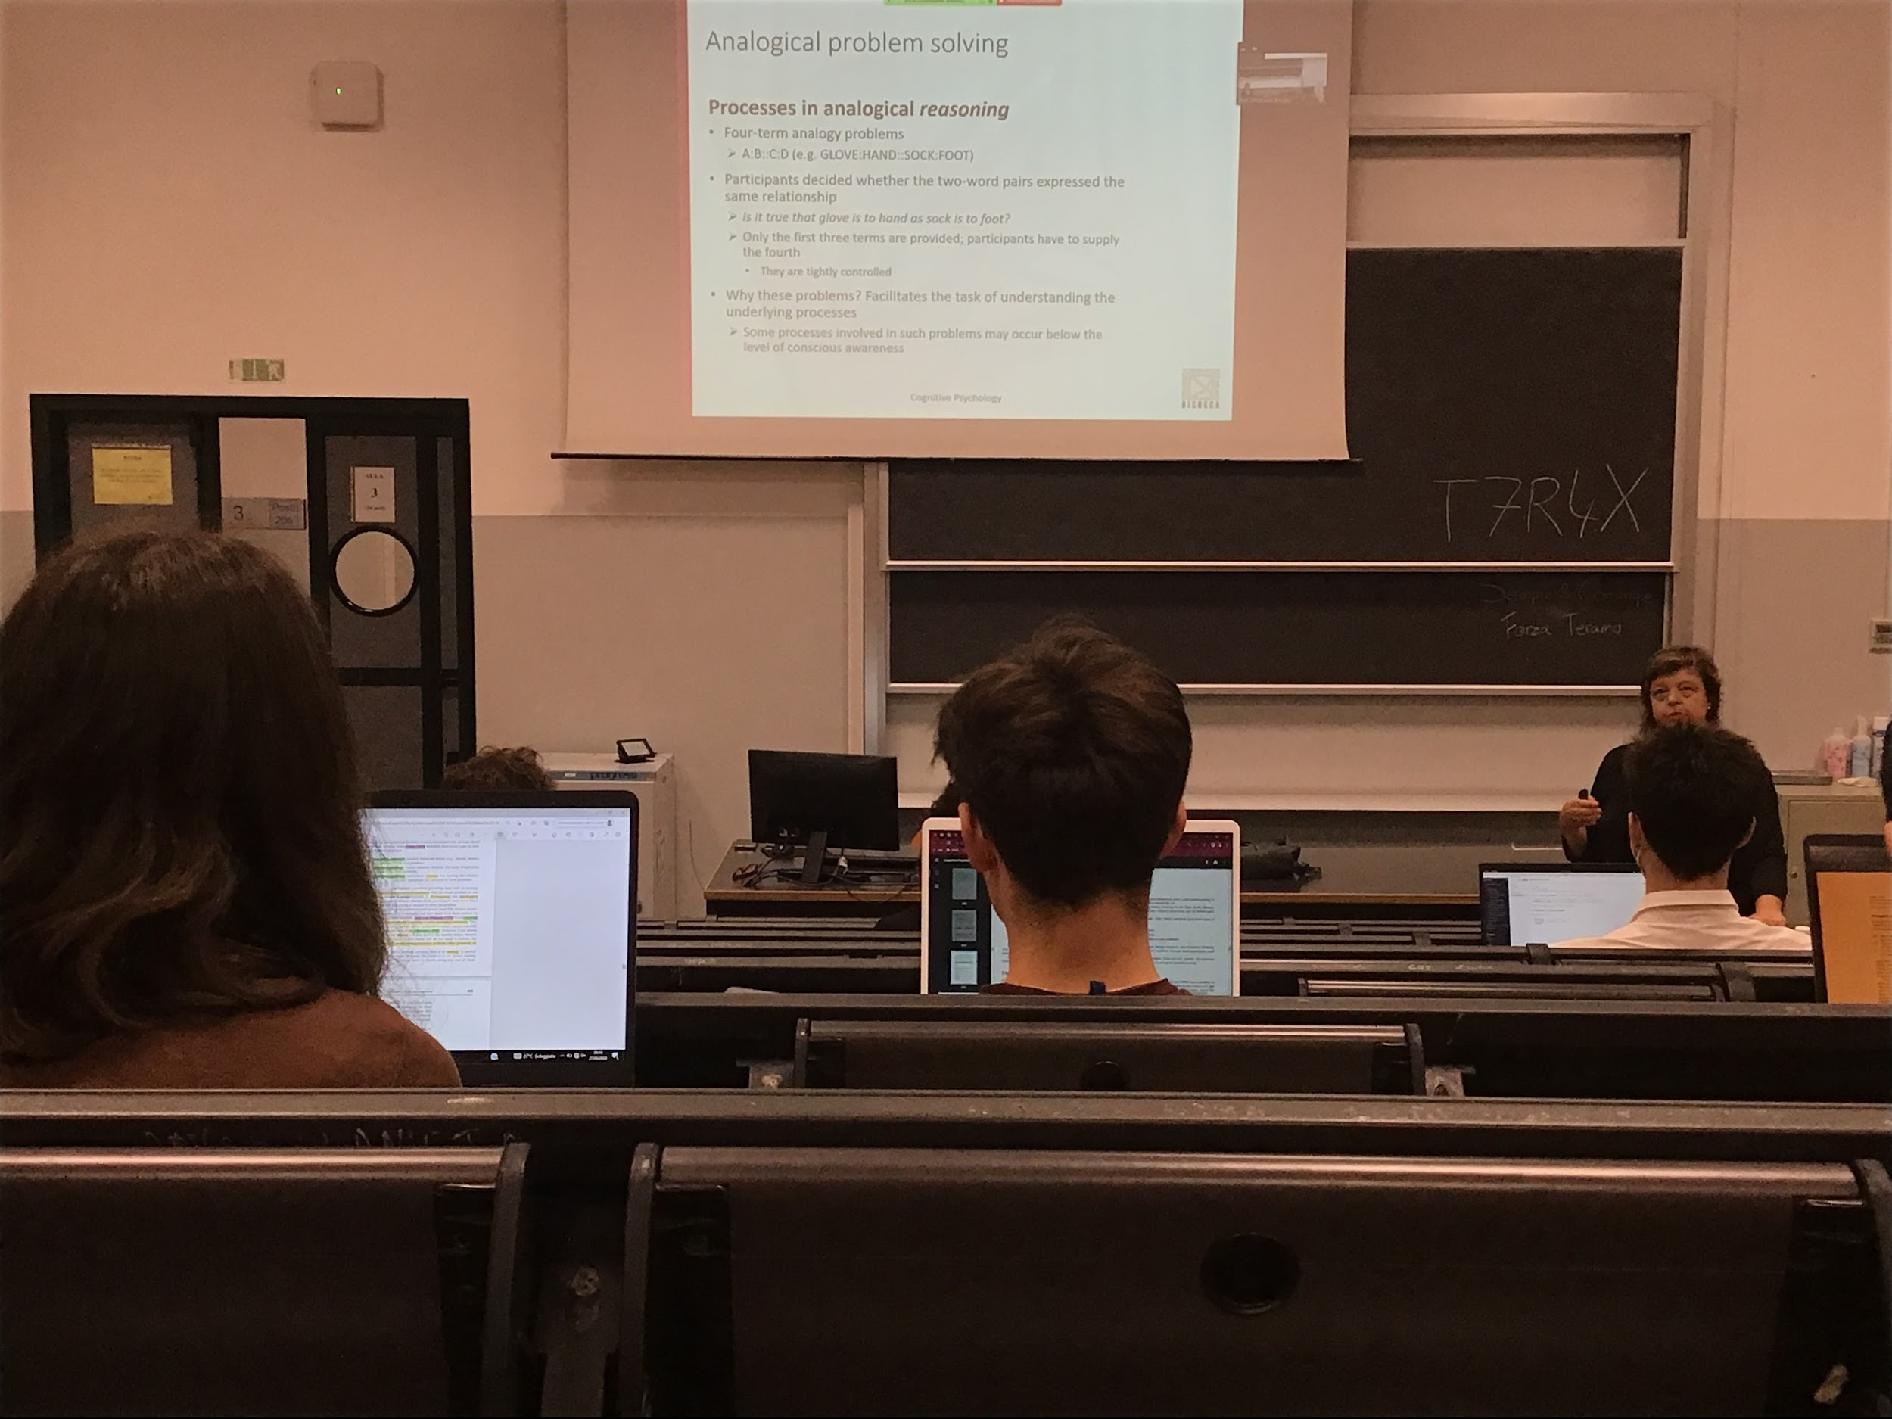

Test this ability with the 4 terms analogy problem

Easy for the psychologist to test. When we have to process analogies it happens in 4 sequential steps

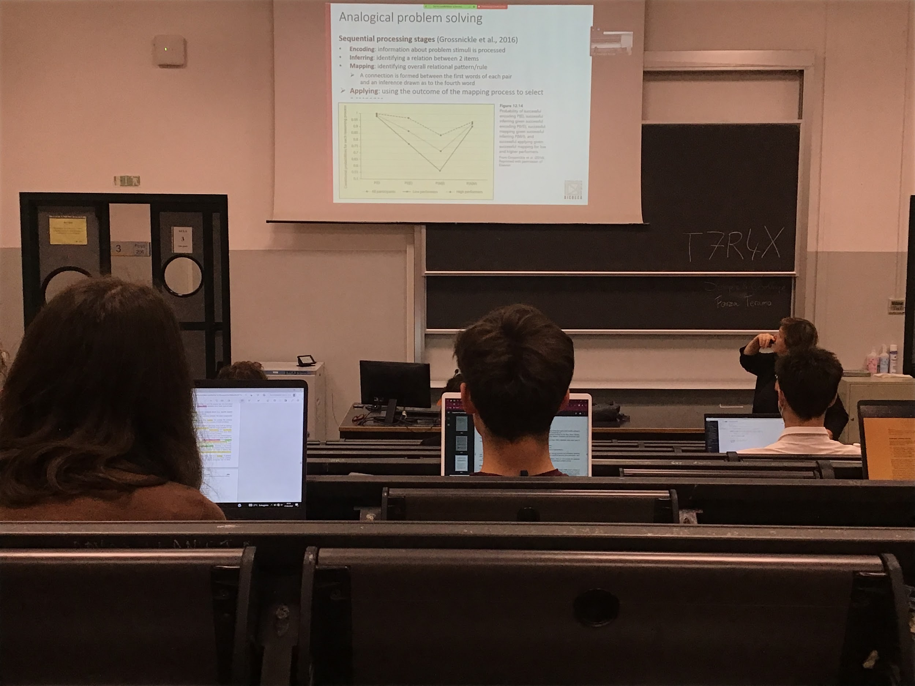

* **Encoding**: try to understand what the different objects are
* **Inferring**: try to understand what is the relation between 2 of the 4 items of the analogy
* **Mapping**: find a pattern and understand what is going on
* **Apply**: the solution to test if it is correct

Most difficult step: inferring and mapping

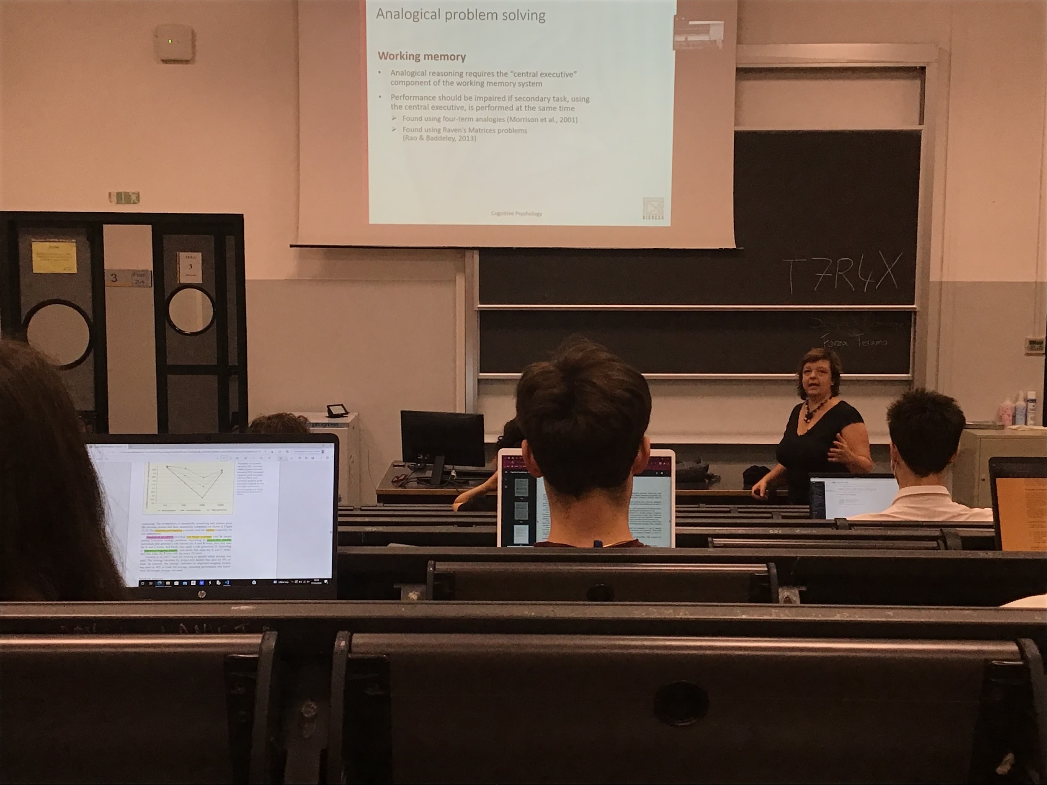

Being able to solve an analogical problem: we need to put in relation different items, compare different concepts.

It is what working memory does: **every decision in every moment uses working memory**.

If working memory is used for analogical problem solving we should be able to show interference. If you need to do something different with working memory you should perform worst while doing analogies

Found that when we interfere with working memory to perform a second task that needs working memory then performance in 4 terms analogies decreases

**So working memory is needed for doing analogical problem solving**

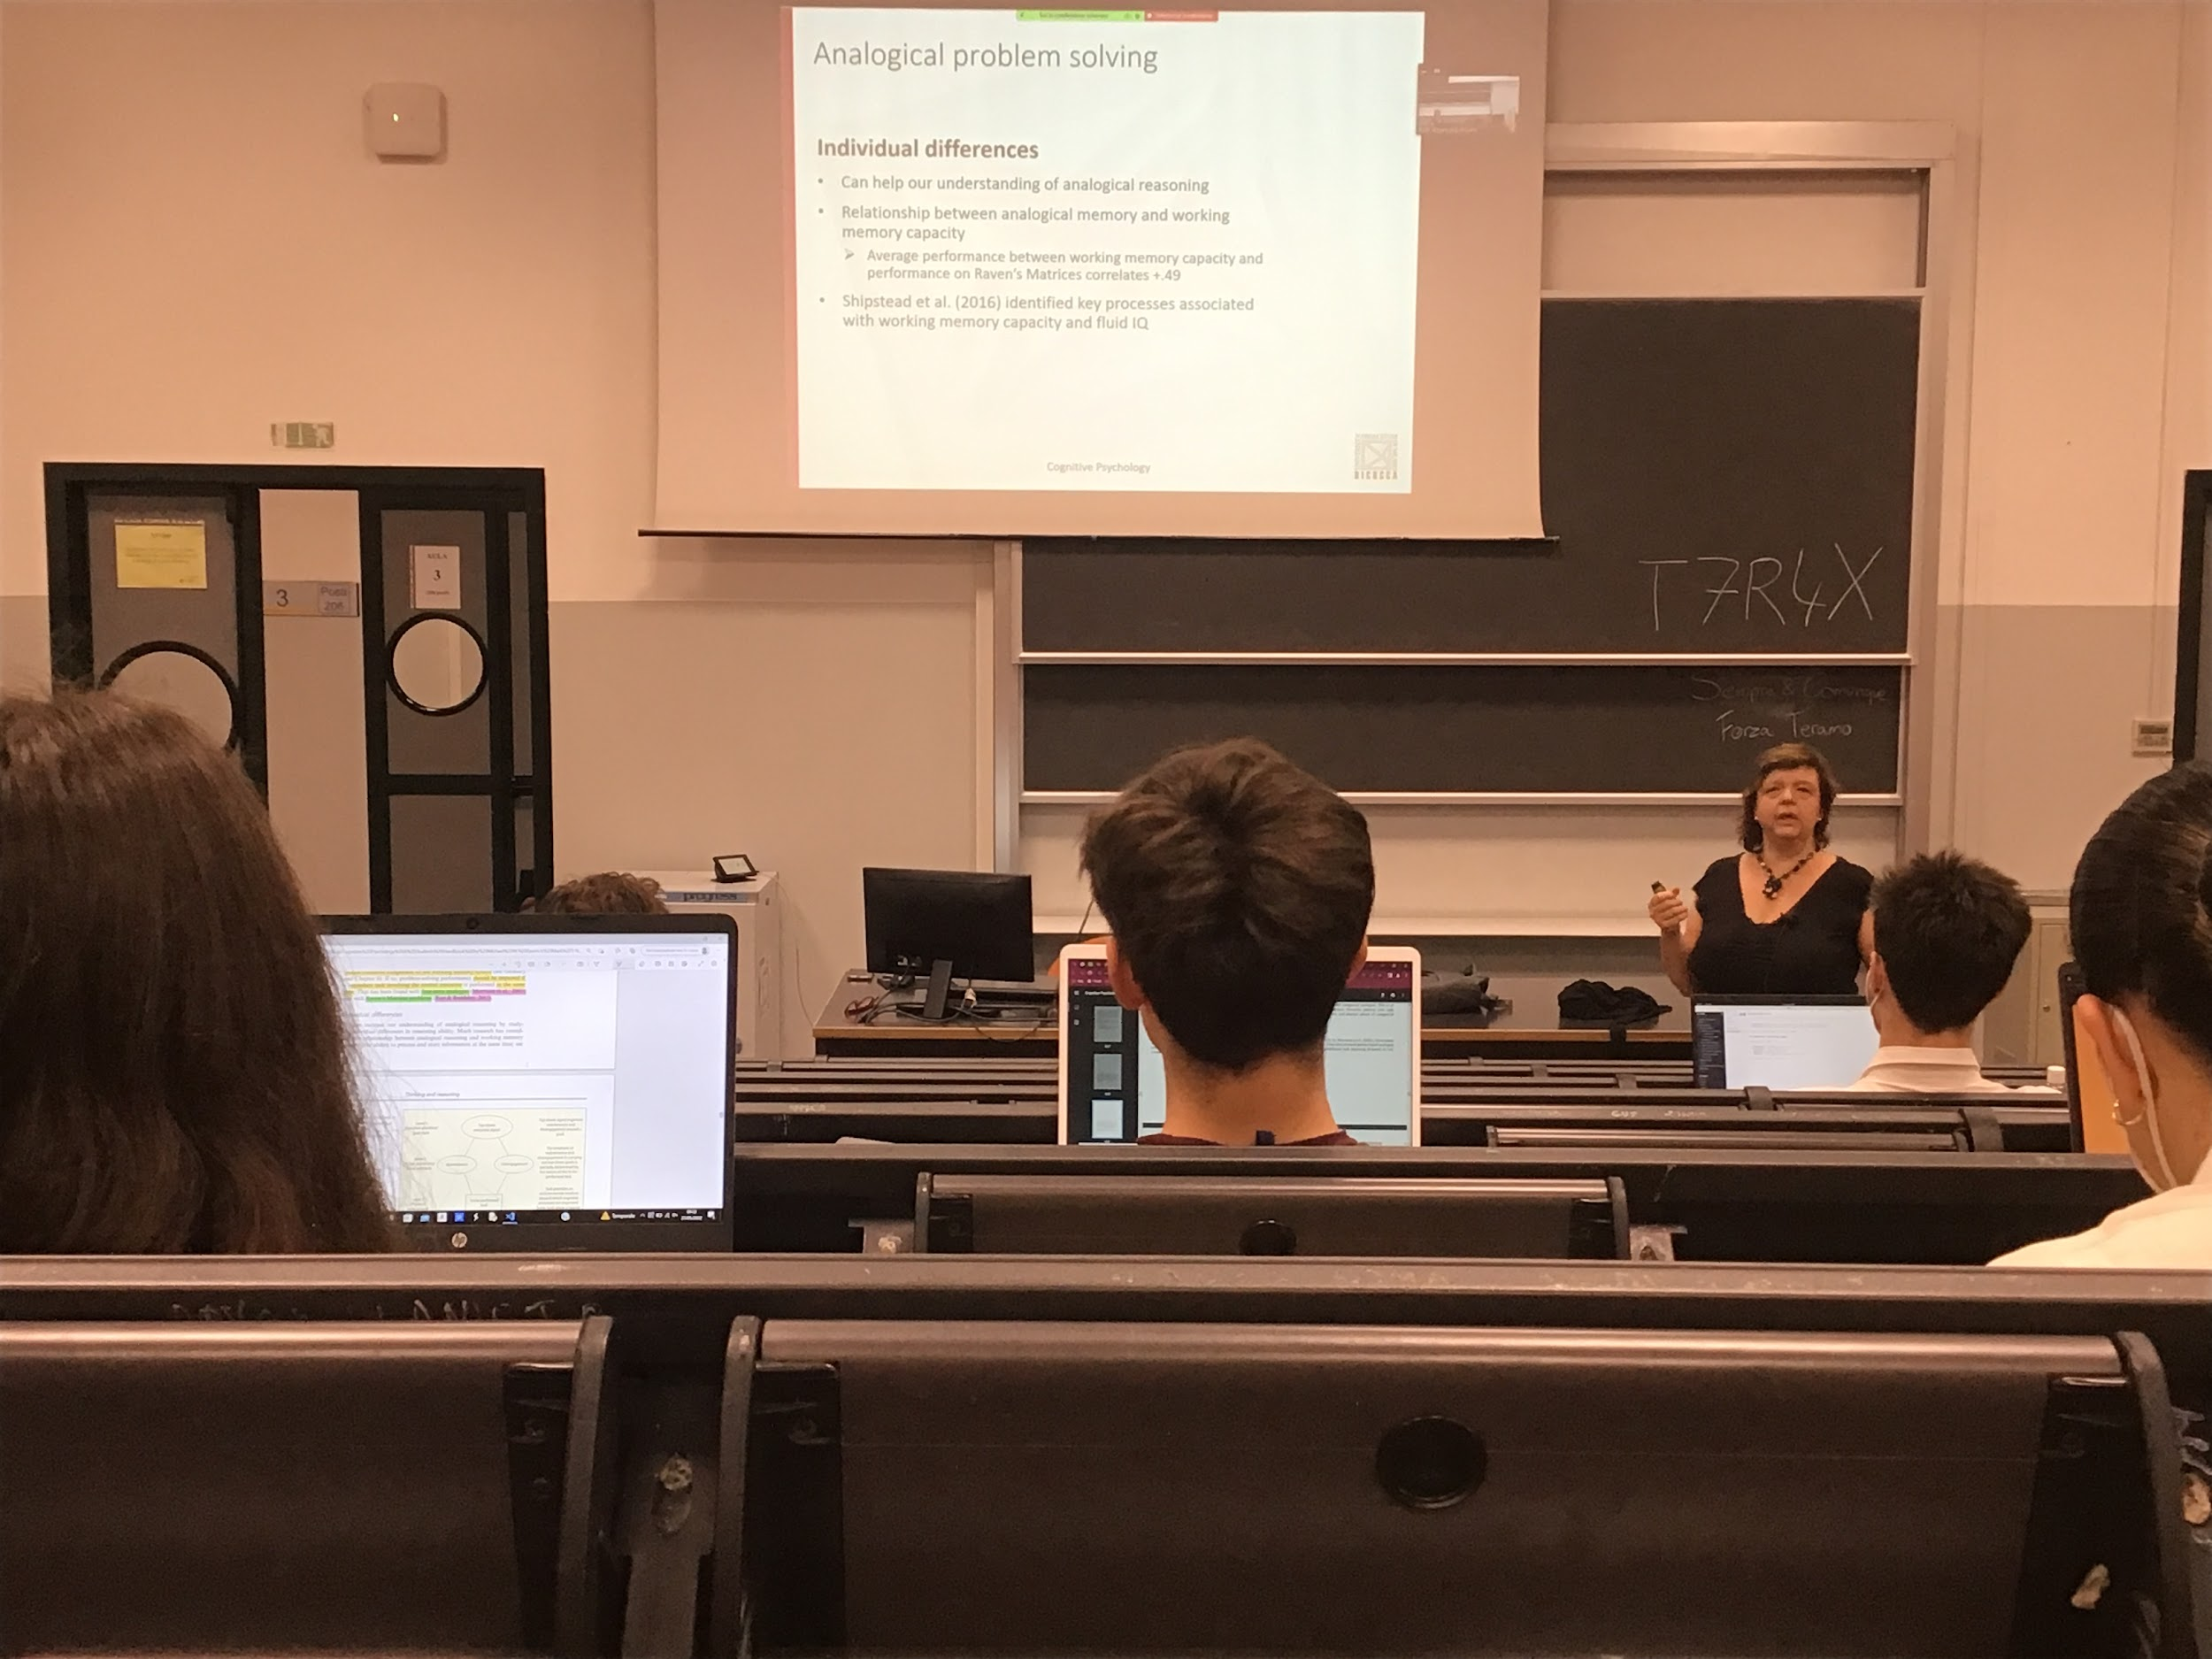

Understand how analogical problem solving is done:

Try to compare different people in the way they solve different problems

If we can correlate different characteristics of different performance, we can understand how this works.

People with high working memory capacity should perform better in analogical problem solving

Working memory correlated with fluid IQ (ability to solve novel problems)

People studied the relationship between fluid IQ and working memory capacity.

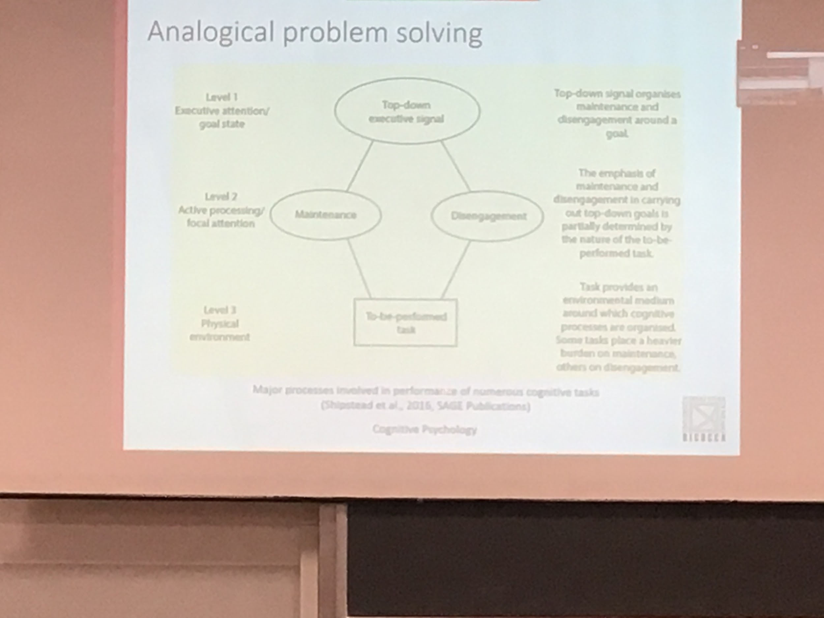

There is a general executive central that is a top-down signal that coordinates the task and there are 2 processes that can be use to perform task

Maintained informanation:

**Disingament information**: ability to remove information that we understand is not use for our problems

Sometimes with analogies you need to disengage

Most cognitive tasks requires executive attention and it is similar

Fluid intelligence: more correlated with ability to disengage

Working memory capacity: correlated with our ability to maintain

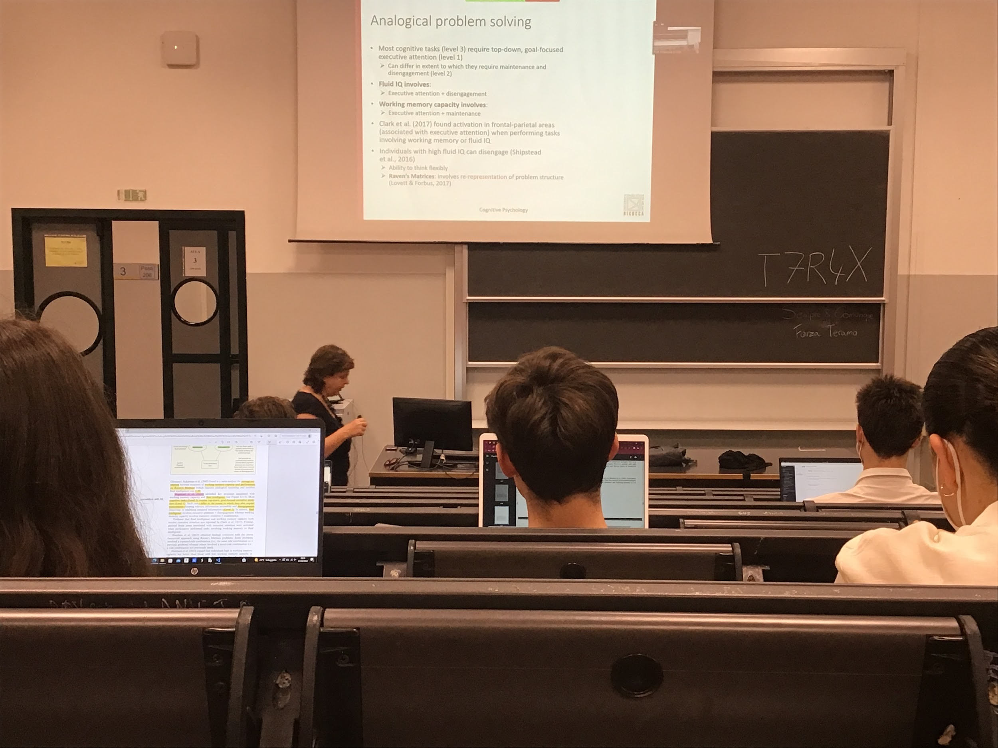

Brain areas involved in this activity: mostly the frontal parietal areas, most correlated with basic sensory processes.

Frontal parietal areas associated with attention and reasoning

Support that fluid IQ is important for analogical problem solving: Individual with high fluid intelligence can easily disengage and this helps to find the solution

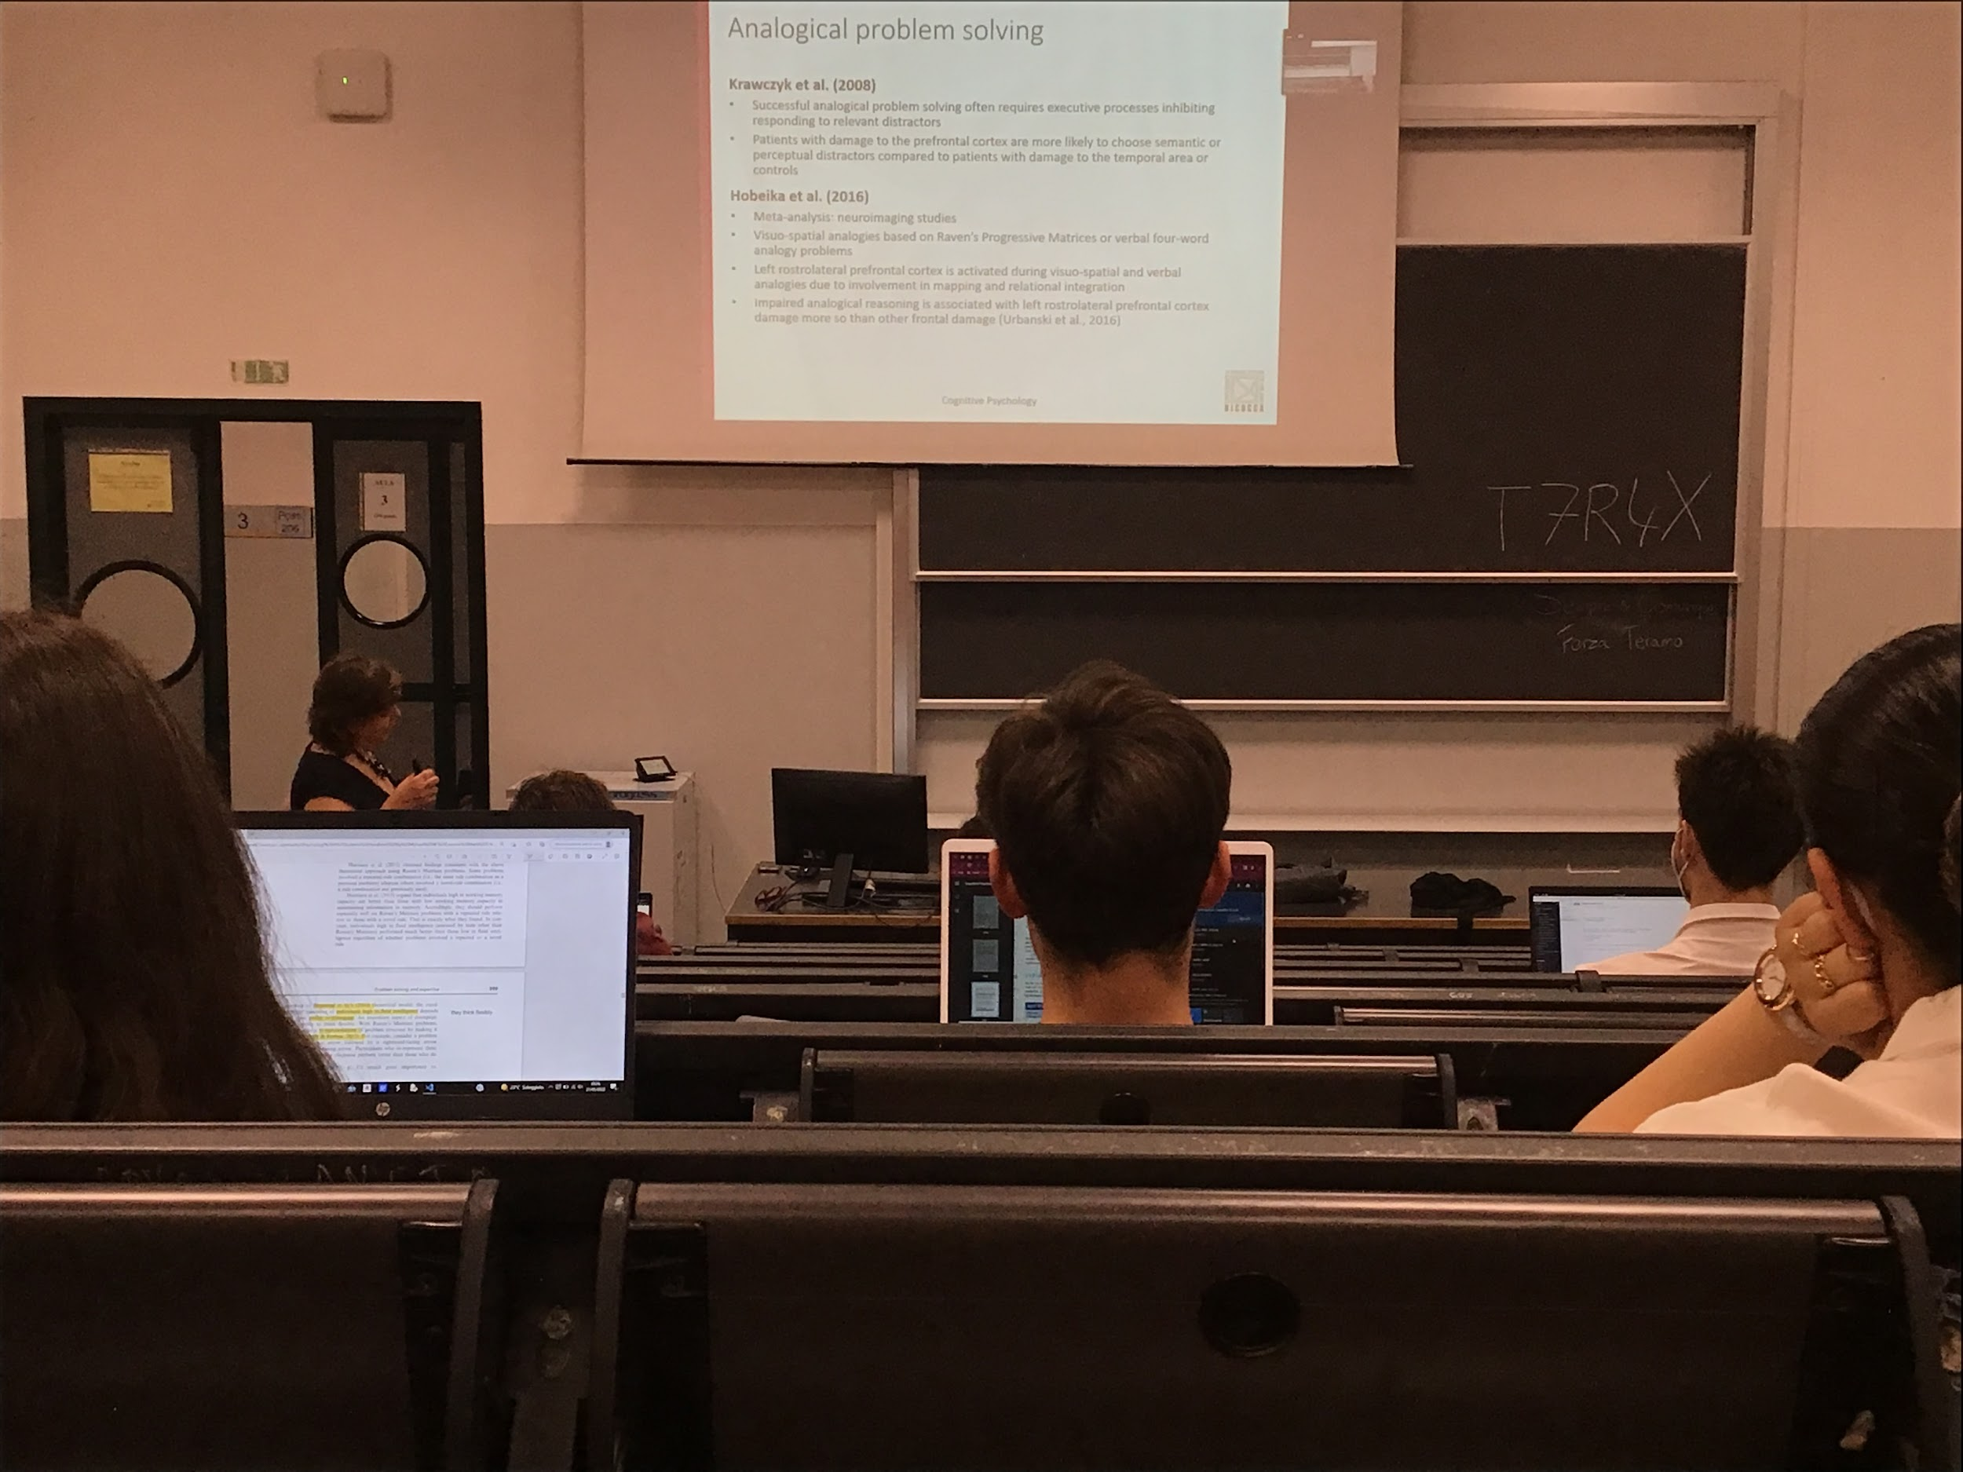

We need inhibition of the non important structure and this ability is in the prefrontal cortex. People with this damage can not perform well on this tasks

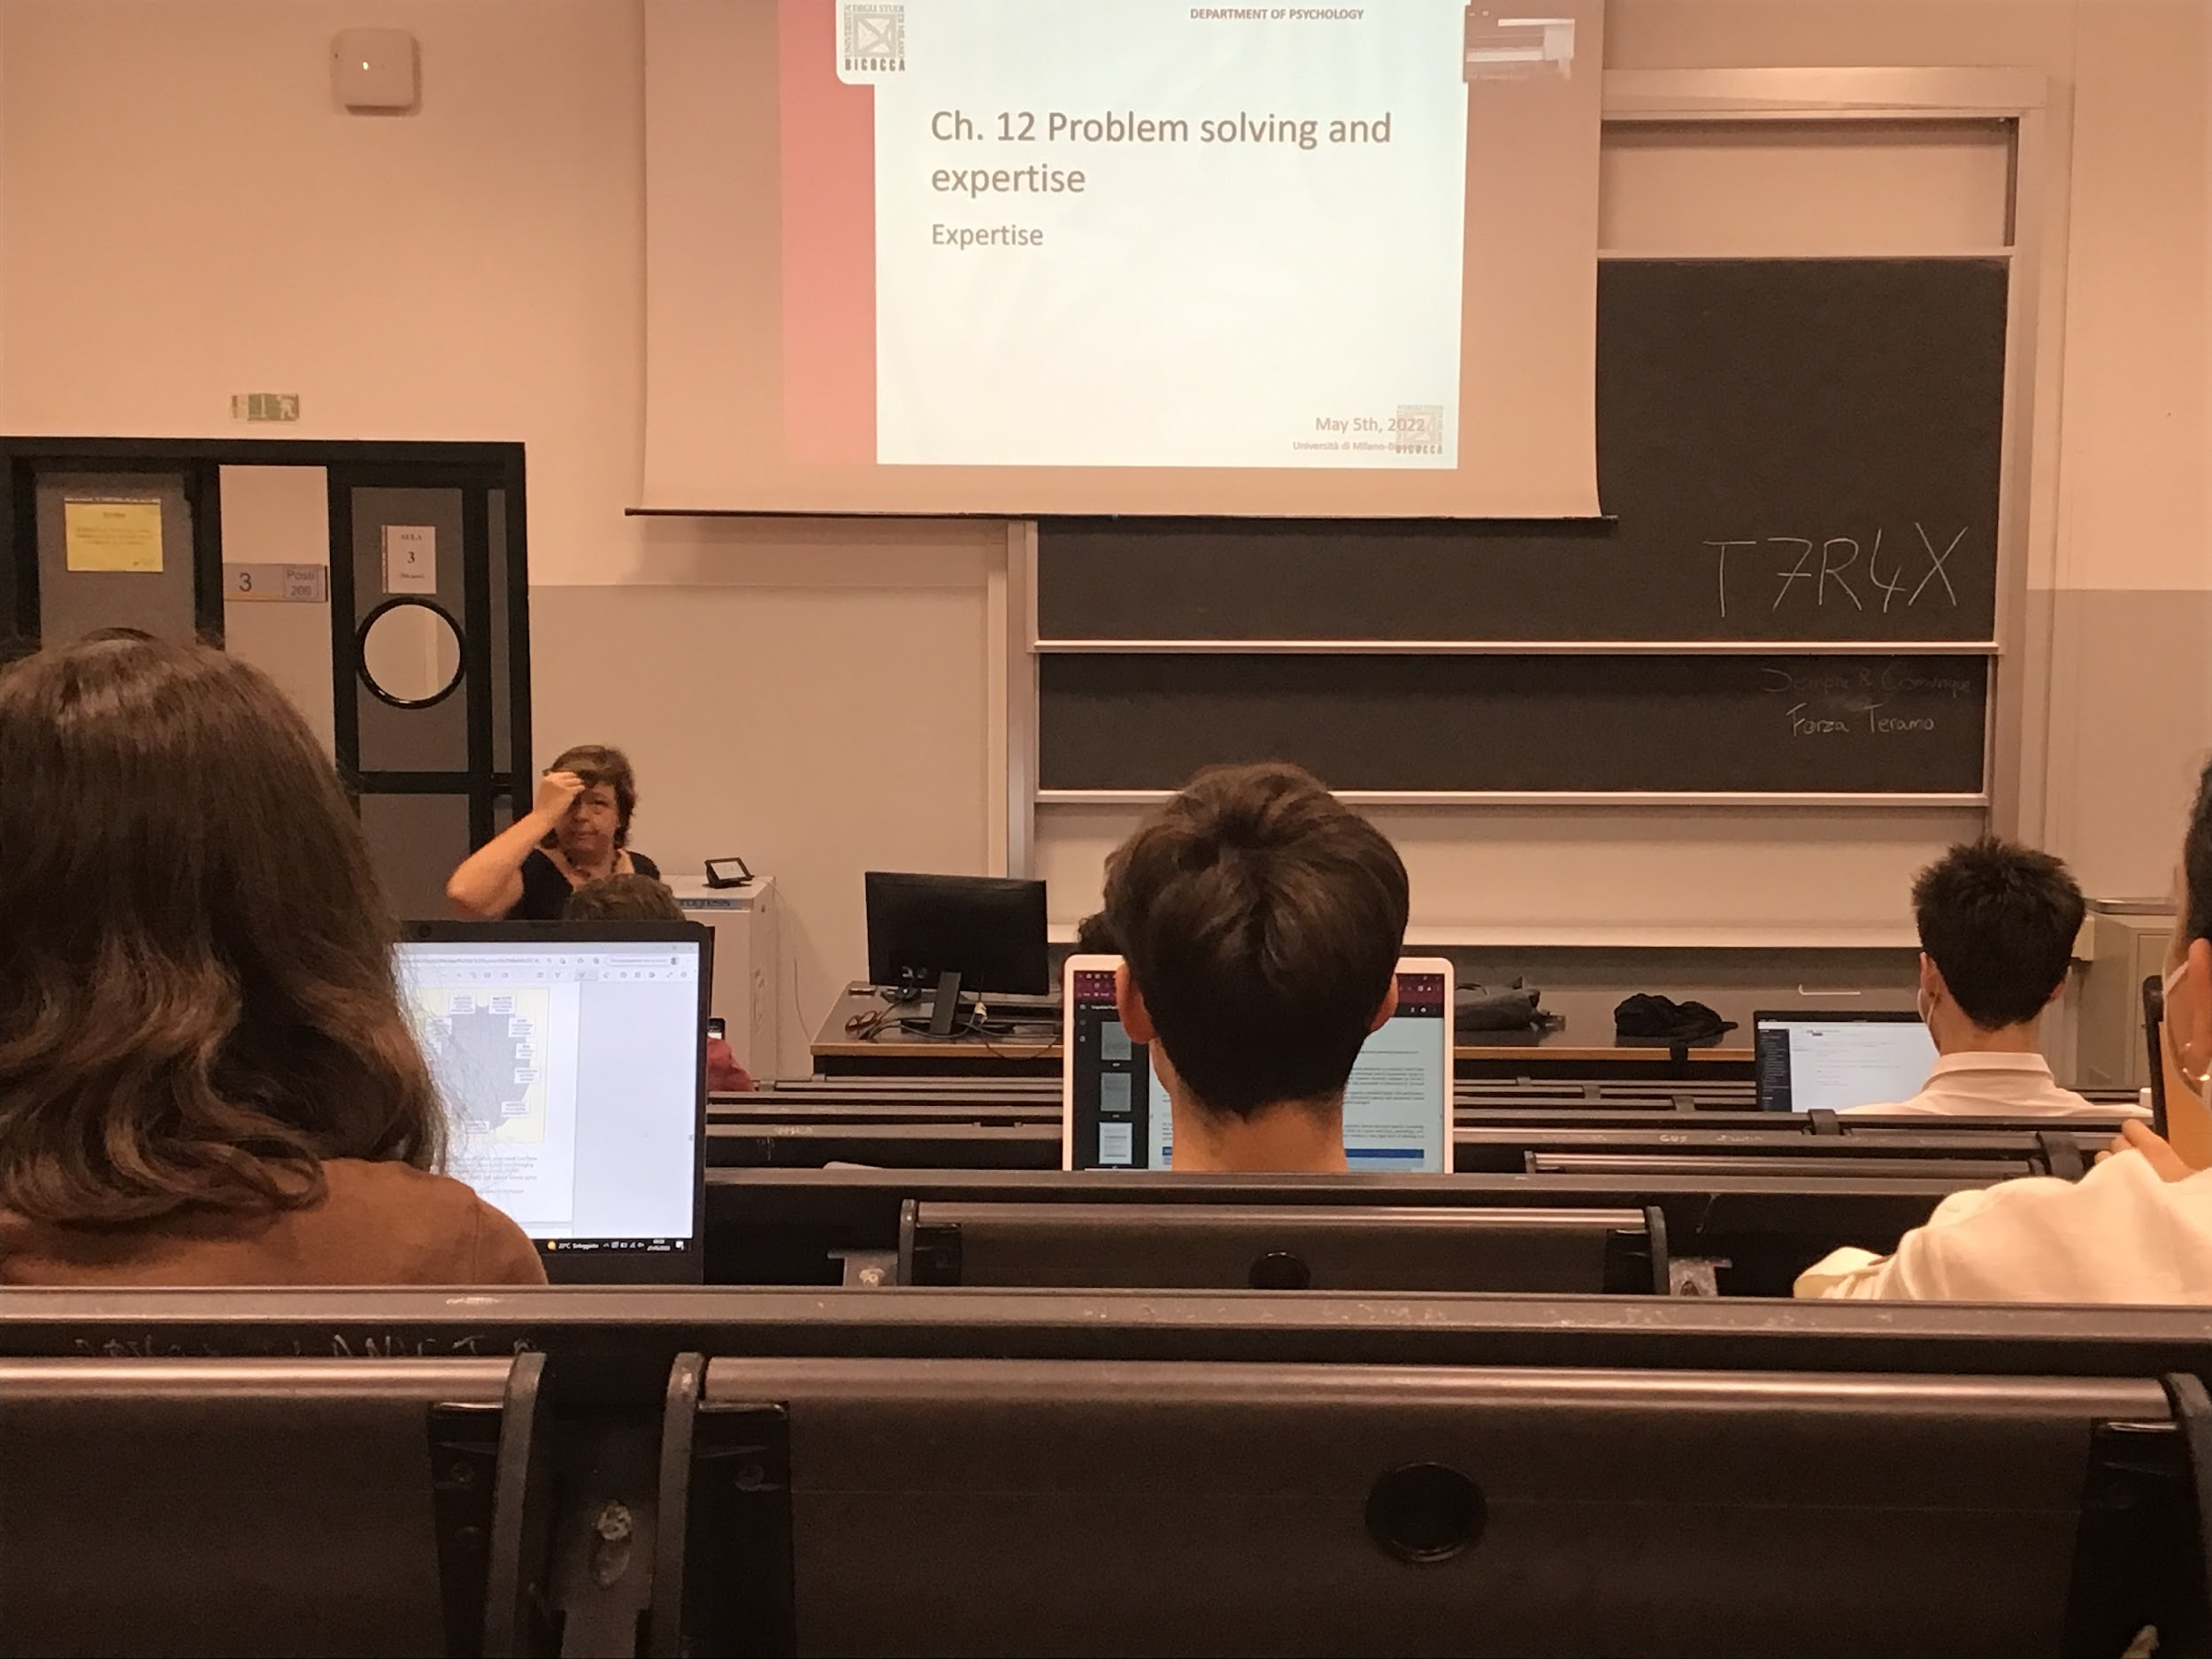

Expertise: up to now we have look at knowledge lean problems, don’t need to be expert

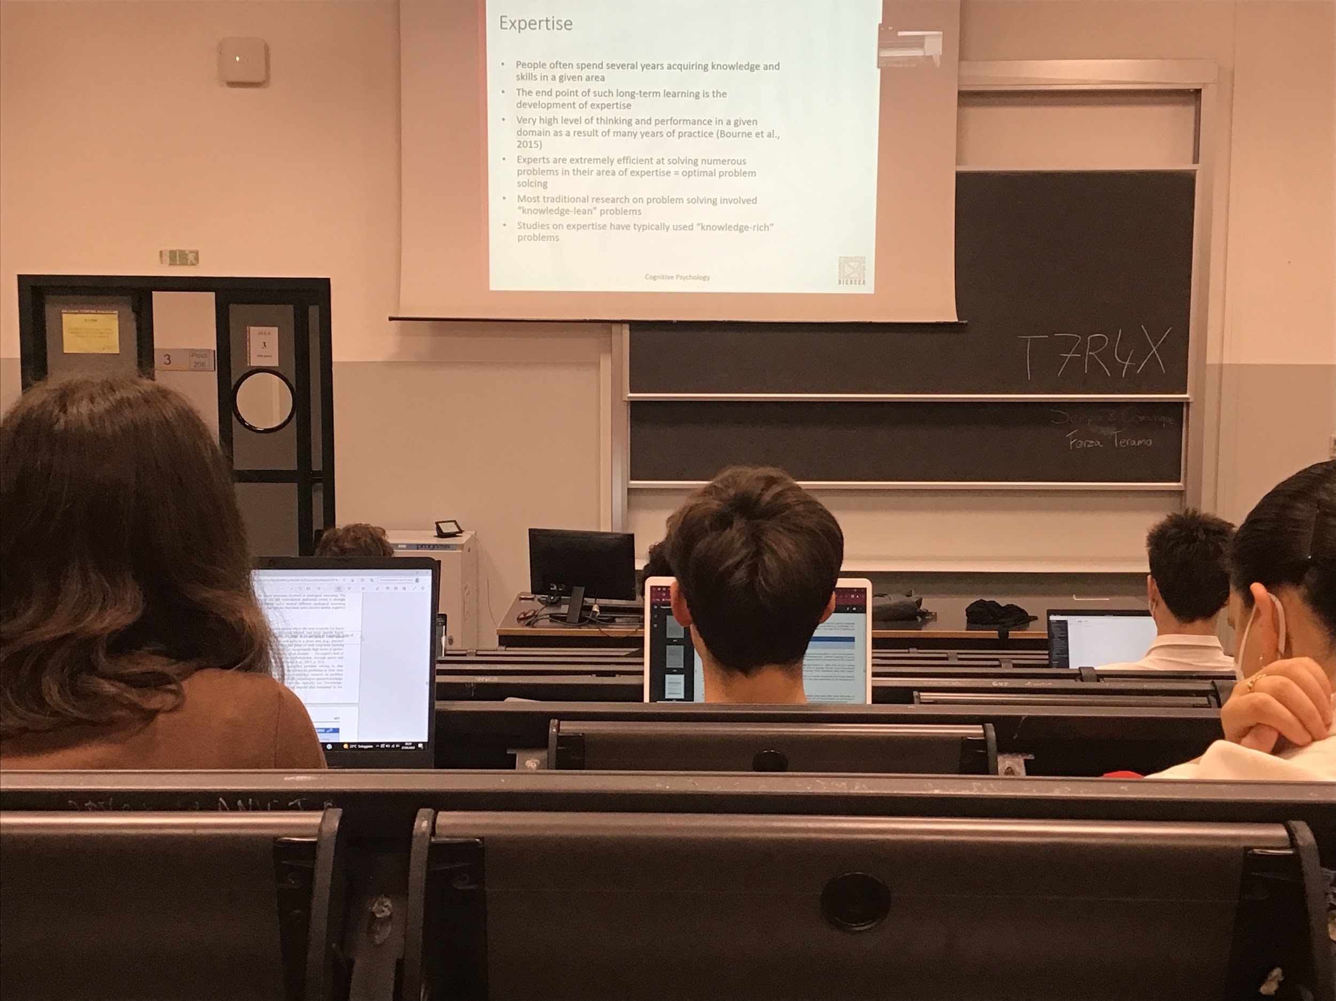

Most people spend several years to acquire knowledge or a skill area

To be able to reach a high-level of problem solving we need to practice a lot

Expert are extremely efficient in solving problems related to their area of expertise and to test expertise we need to do knowledge rich problems

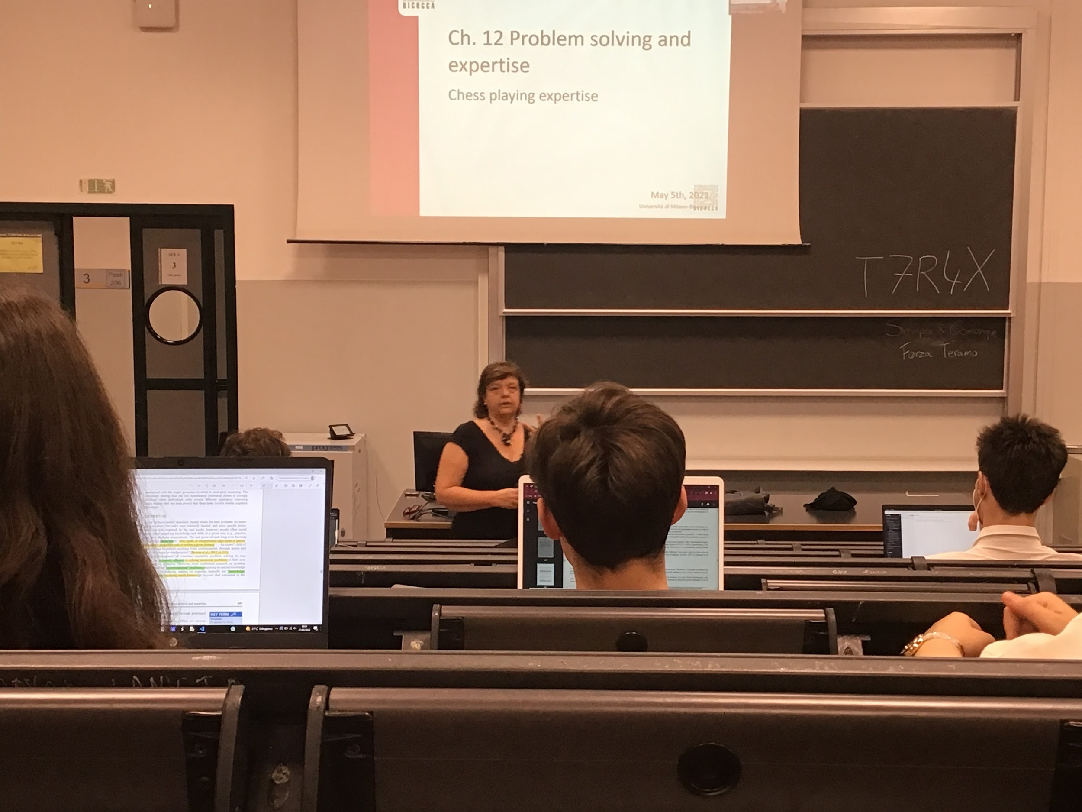

We see that the expertises that develops in two areas are different and they become expert by optimising some kind of abilities

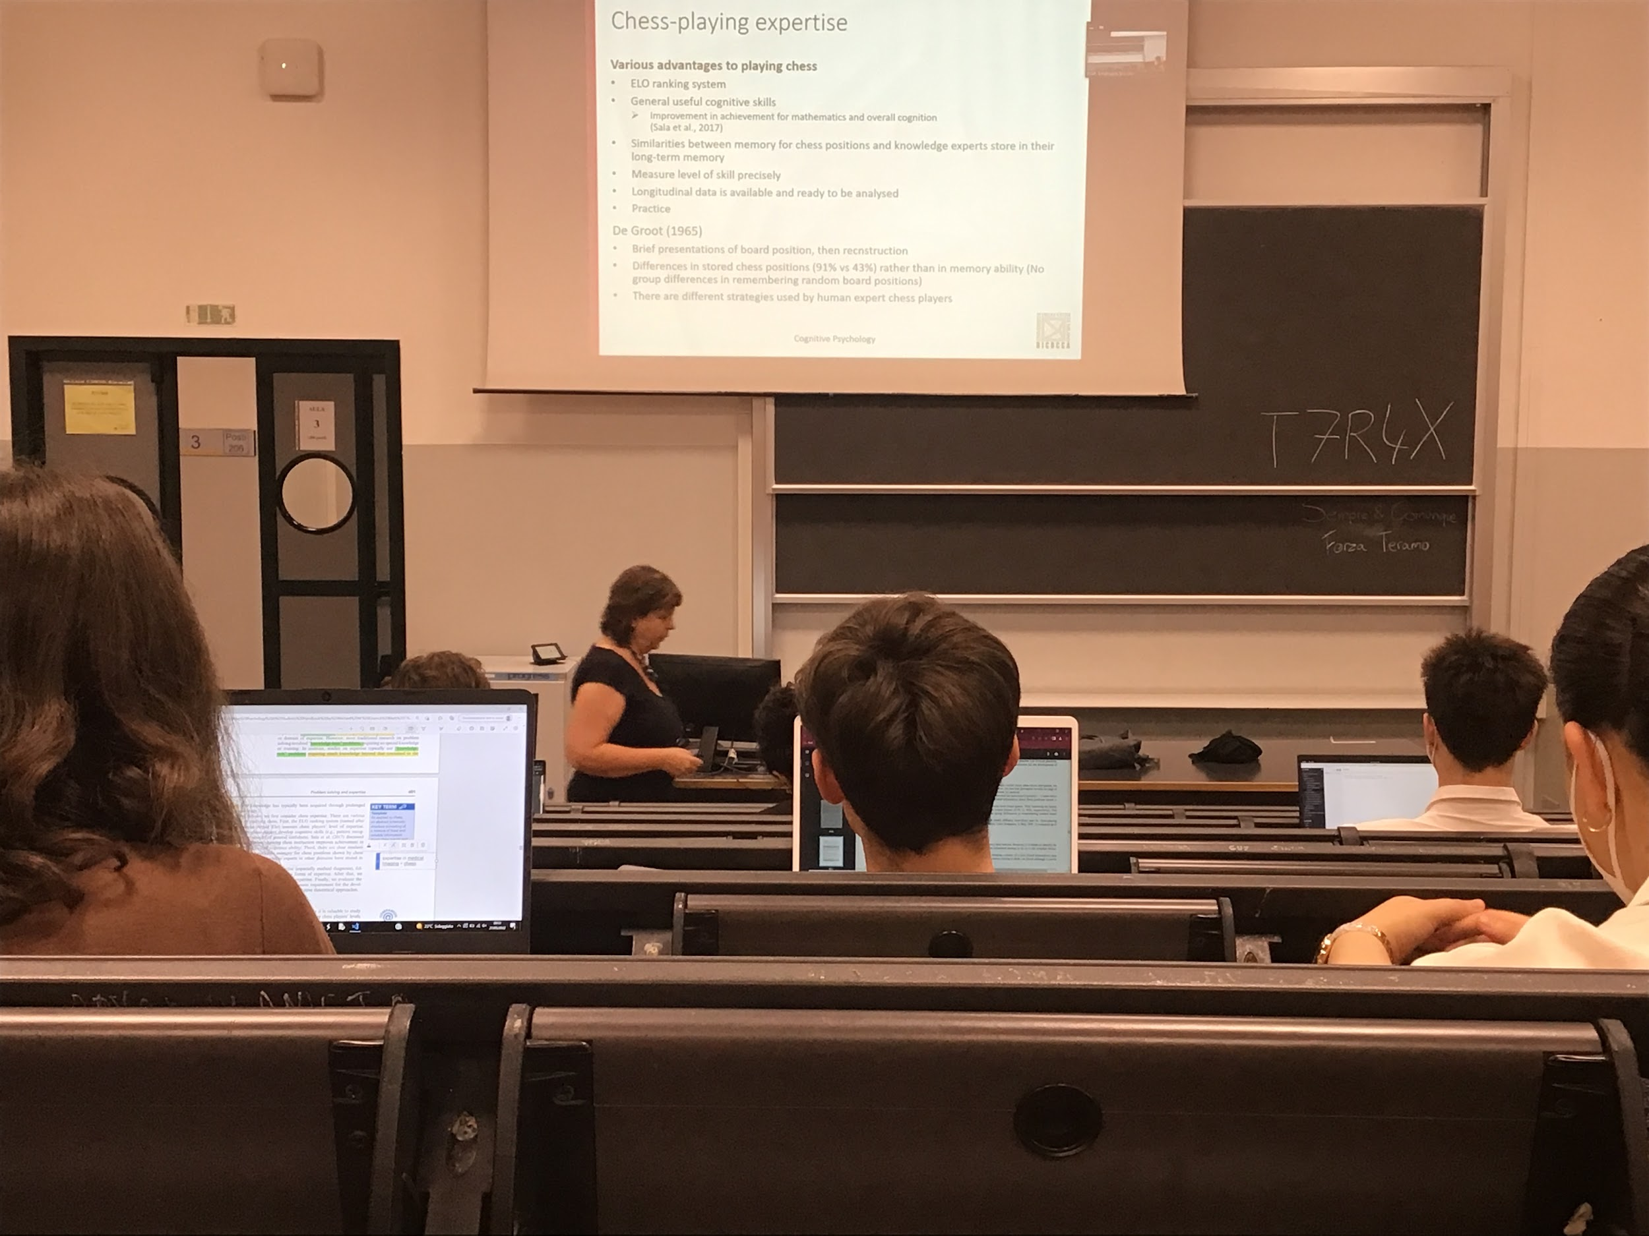

Chess has a very strict ranking system

Chess has a lot of advantages in real life. If you are very good at chess you improve a lot of other cognitive skills (mathematics, overall cognition,…)

Help you solve problem in a different way

Become able to memorise a lot of chess distribution, they store information in LTM

How do you test expertises? Make the same test with grandmaster and non expert, show for a brief moment a board position and you take it away, and you ask to reproduce on an empty chessboard. A master can reproduce 91% times correct

If I put randomly pieces in an impossible position expert and non expert are equal, same result. Much expert when you show position that can come out

Not a problem of memory, remember actual structured situation

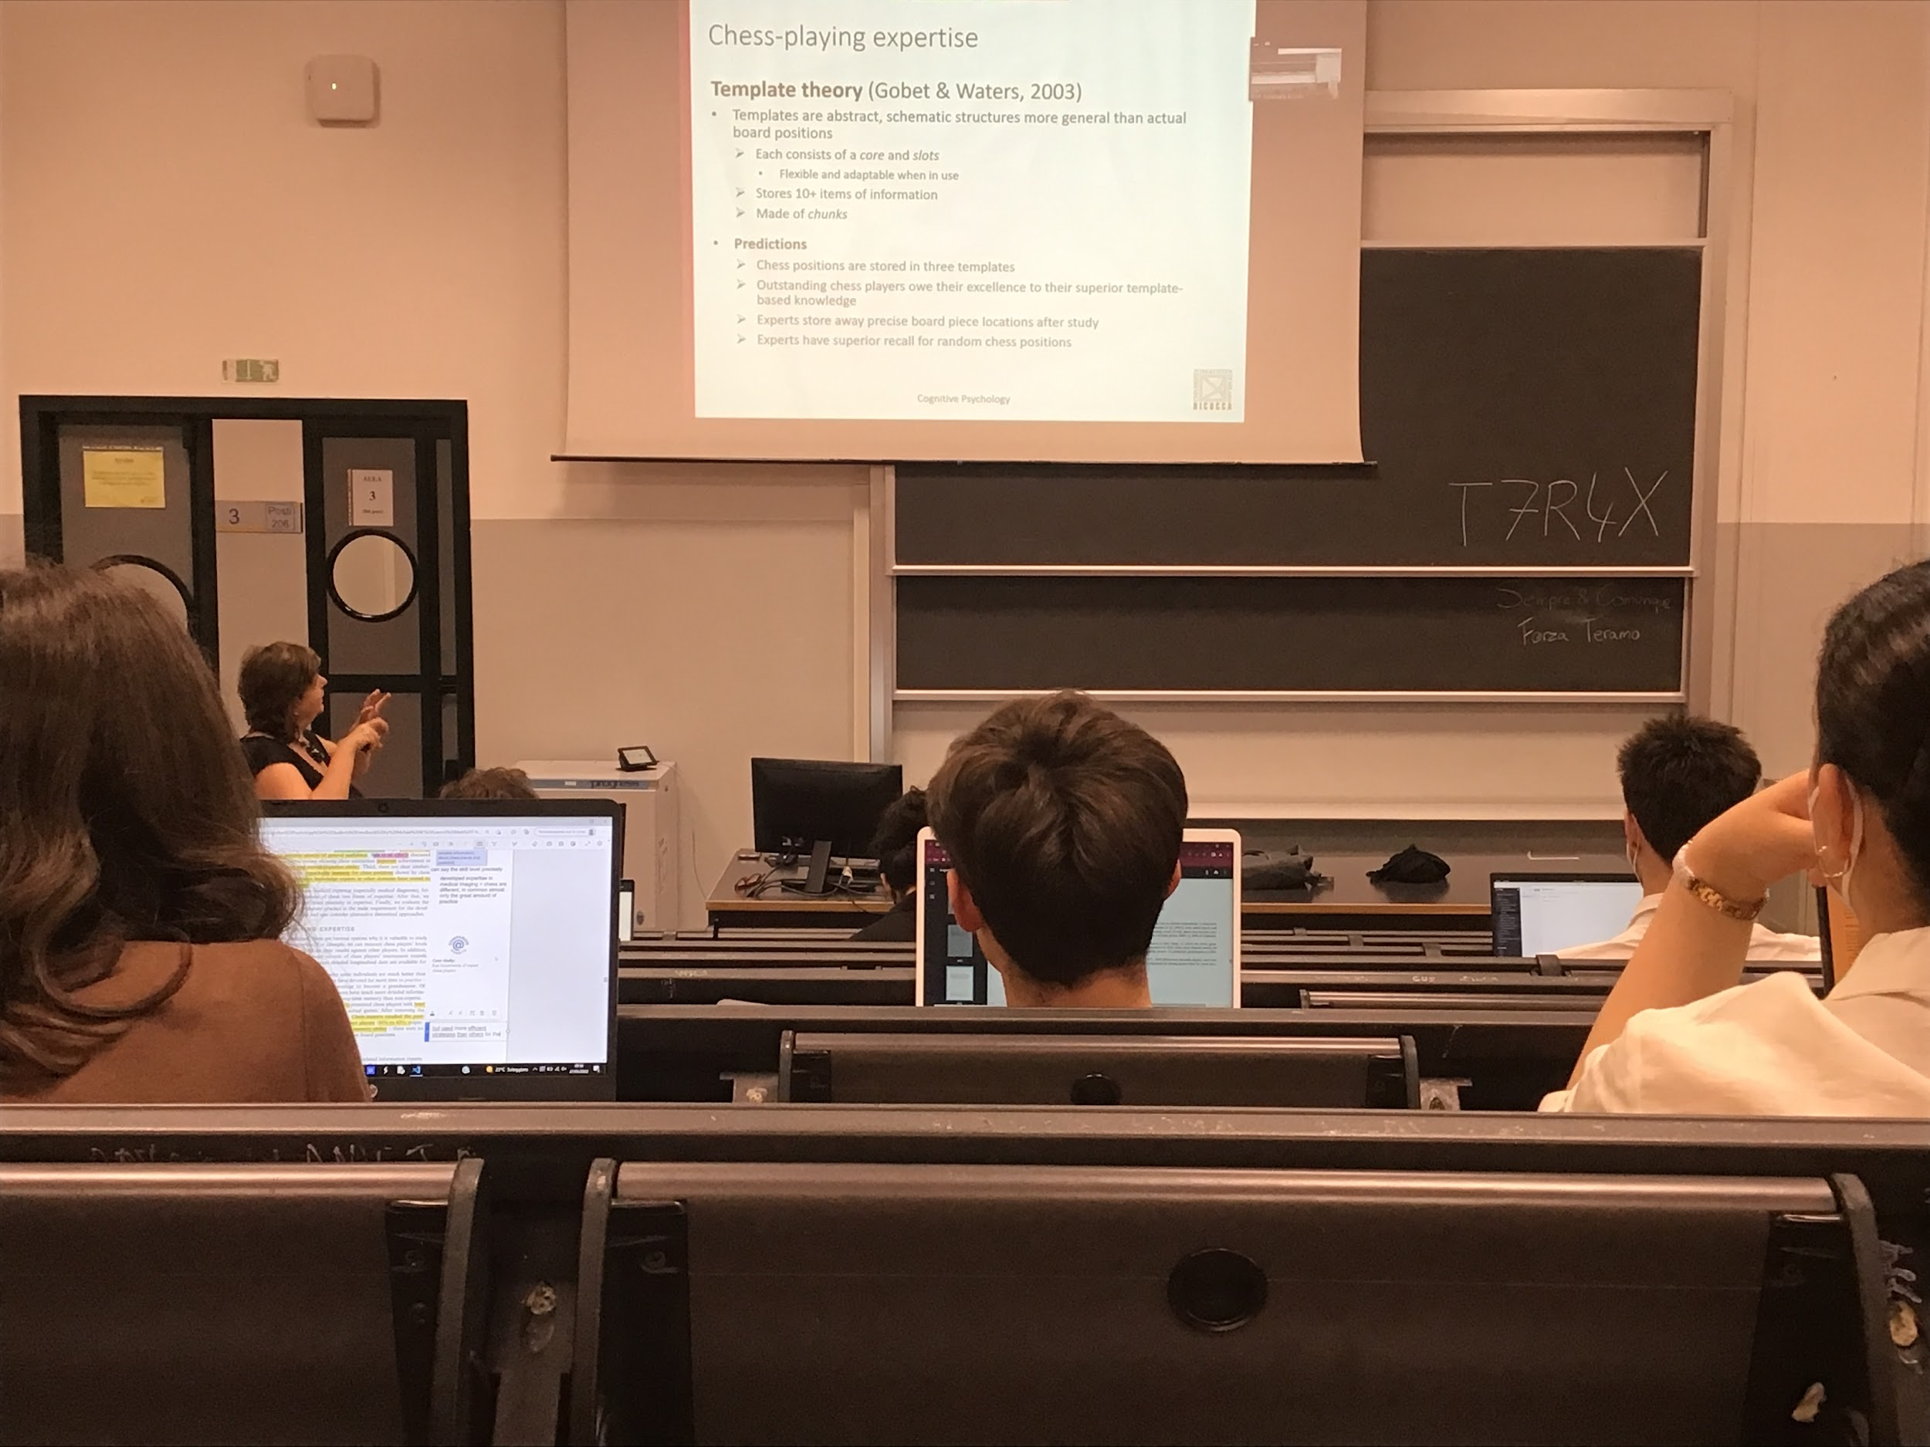

What is the hypothesis, they **store this information in templates**, in an abstract schematic structure that contains fixed information and slots where they can put inside different pieces.

Able to store in this template that are build with experience chess positions

Most of the times they uses a limited number of templates

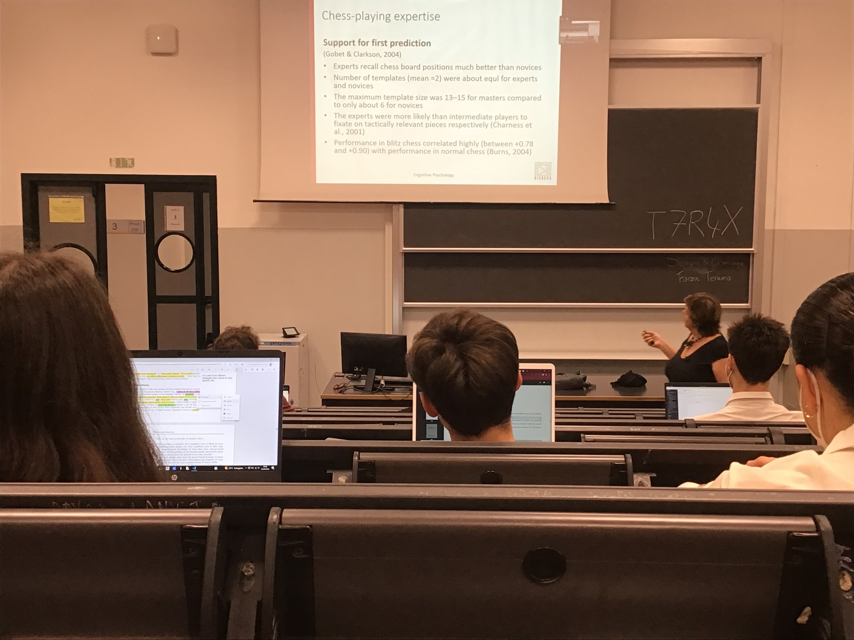

Expert are asked to record board position (much better than novices) and 2 template are used, but master have much larger templates

* Access to the template is very fast
* Chess player expert are better because uses better templates

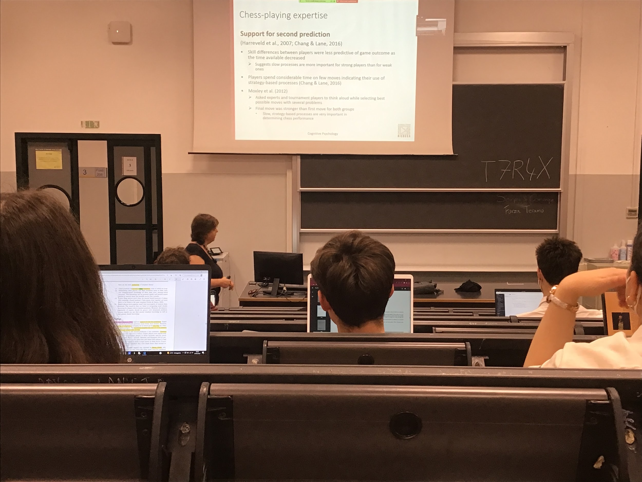

Strong players use the template, but if they have more time they can use more option

Thinking out loud can make understand what people do

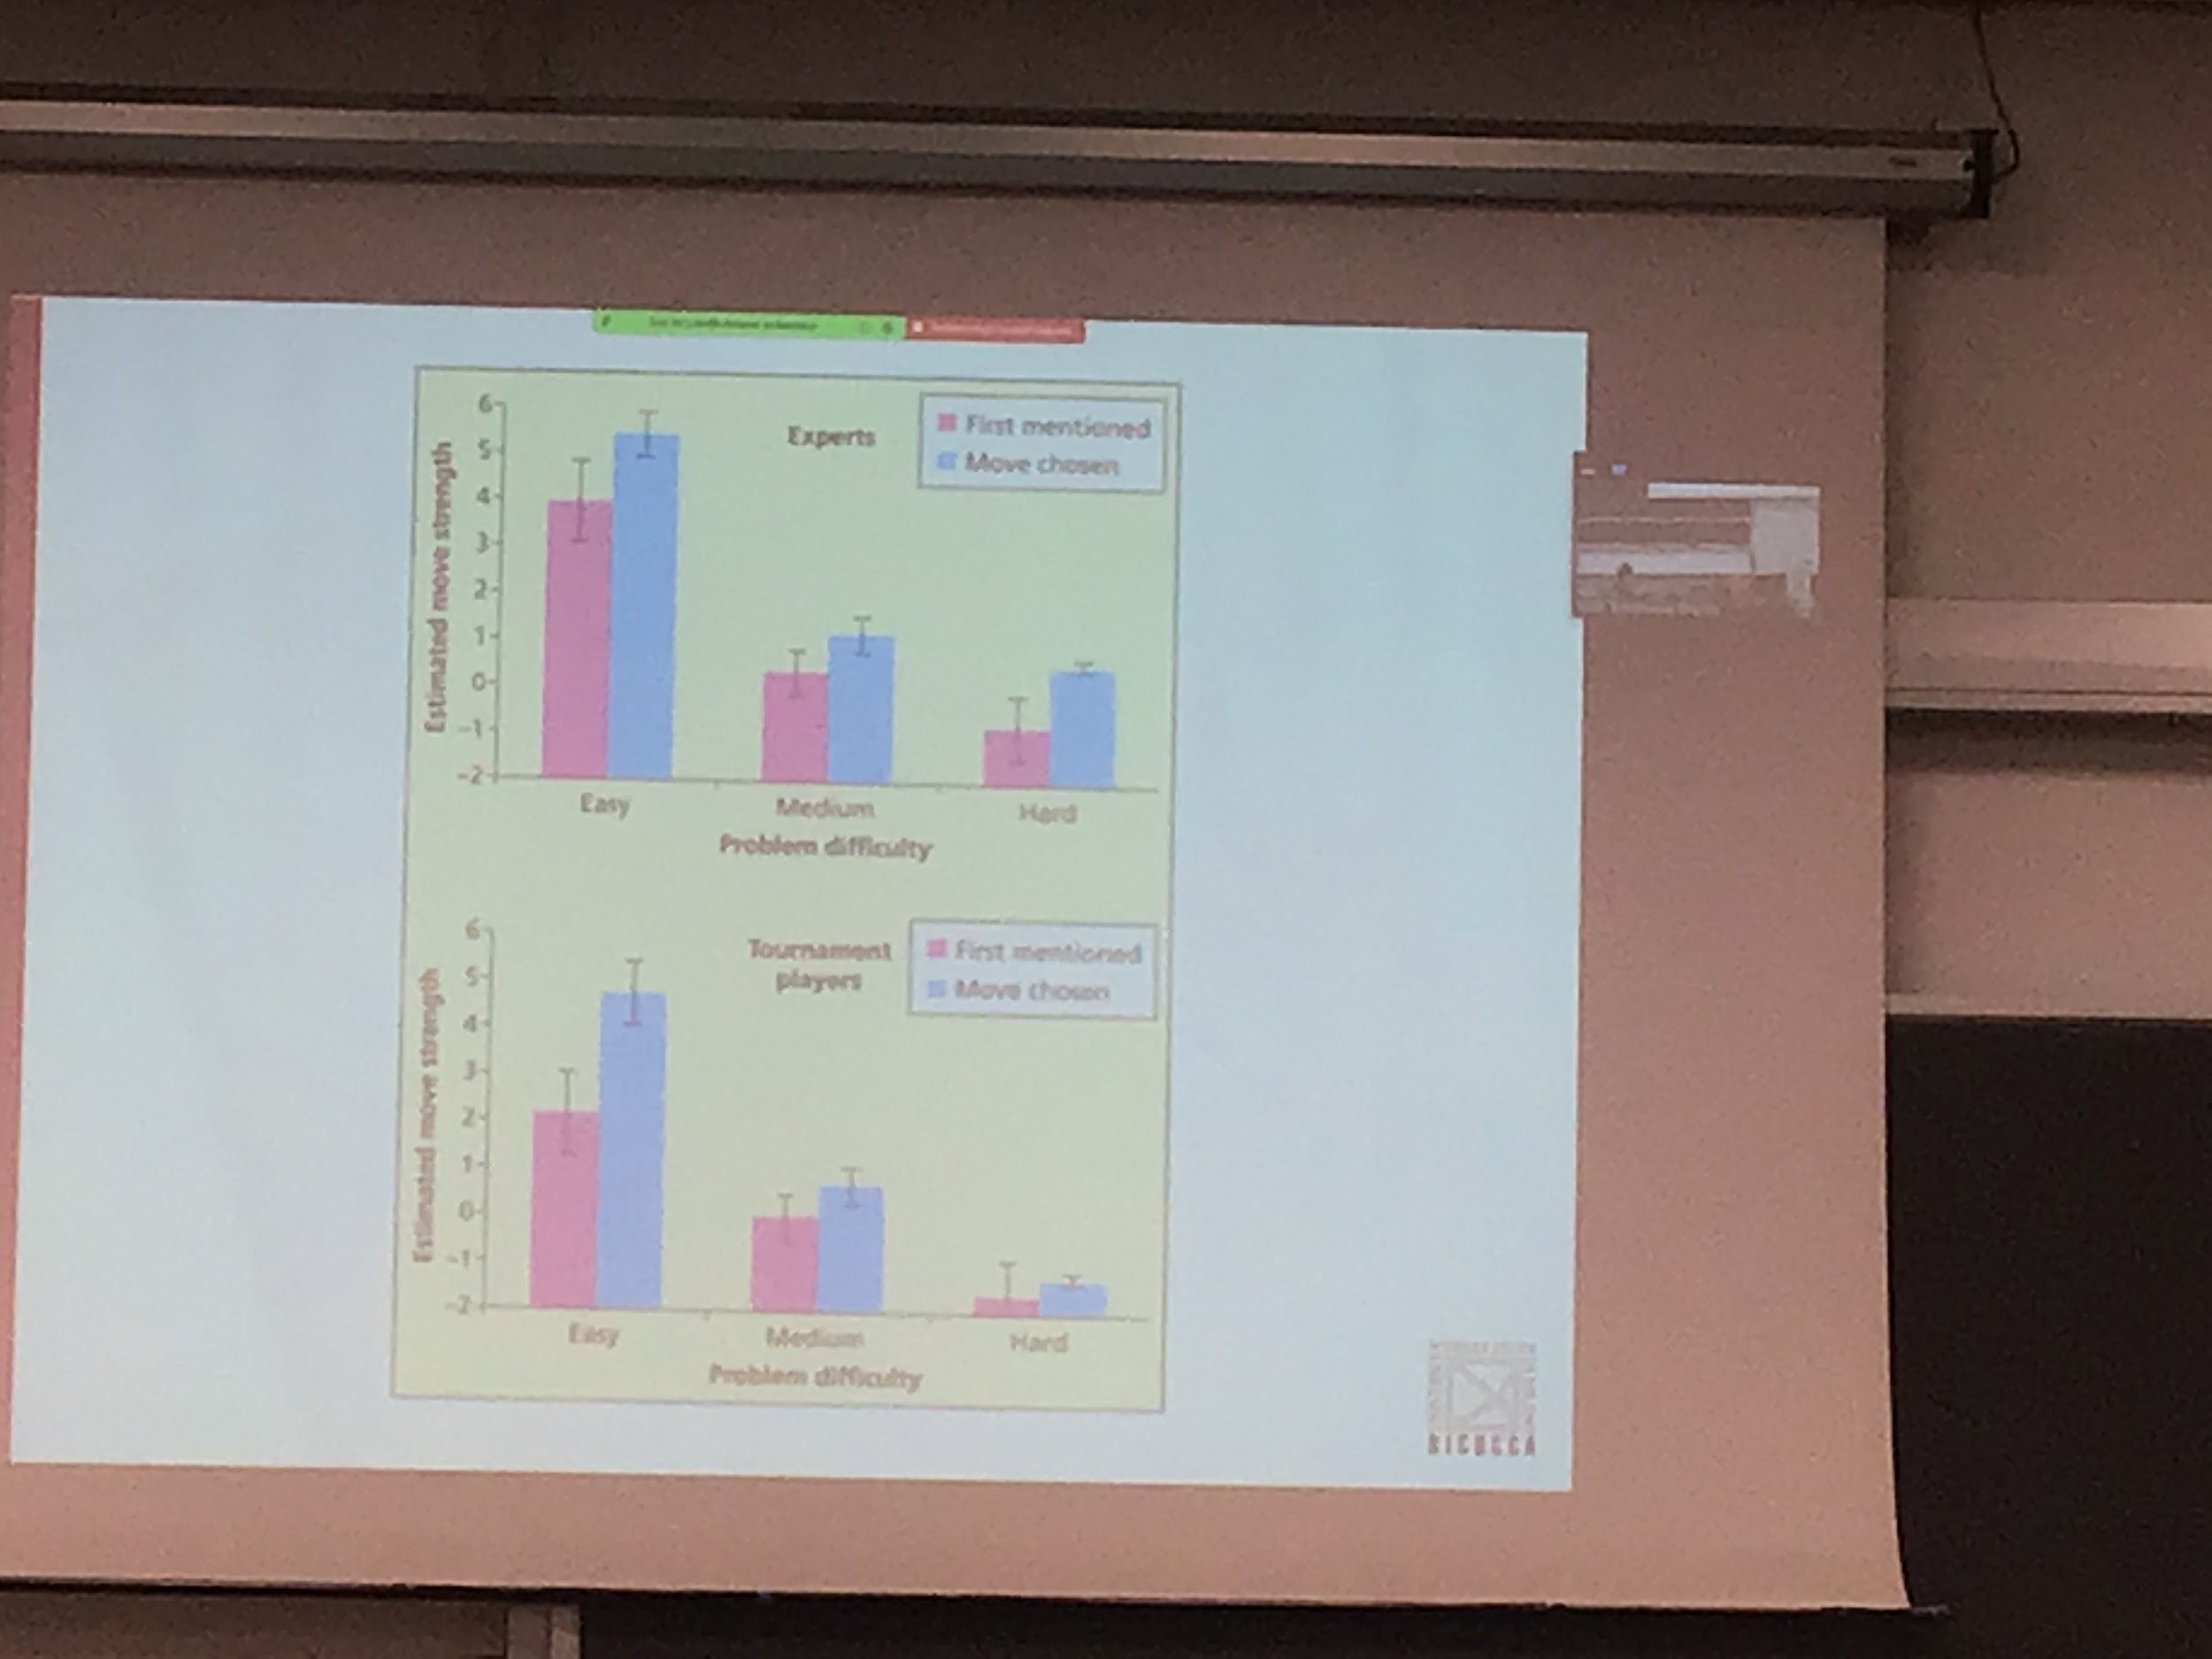

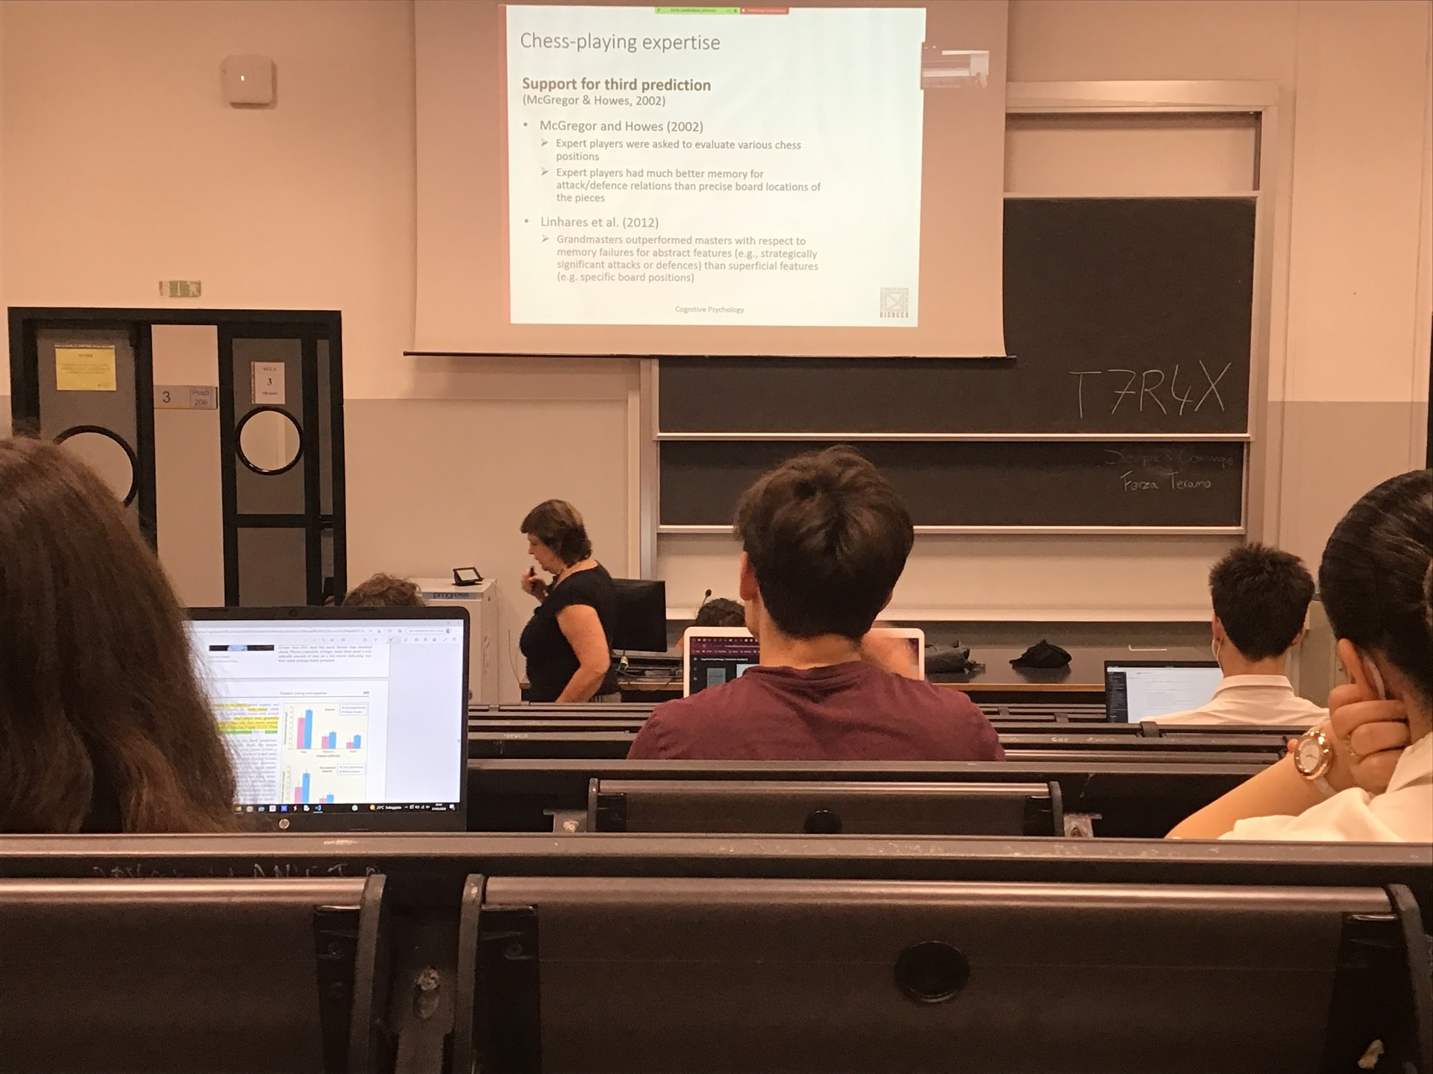

If I show you a board the expert player are more focused on what you can do on that board, **don’t need to know the exact position of the pieces** but rather what you should do (what is your move)

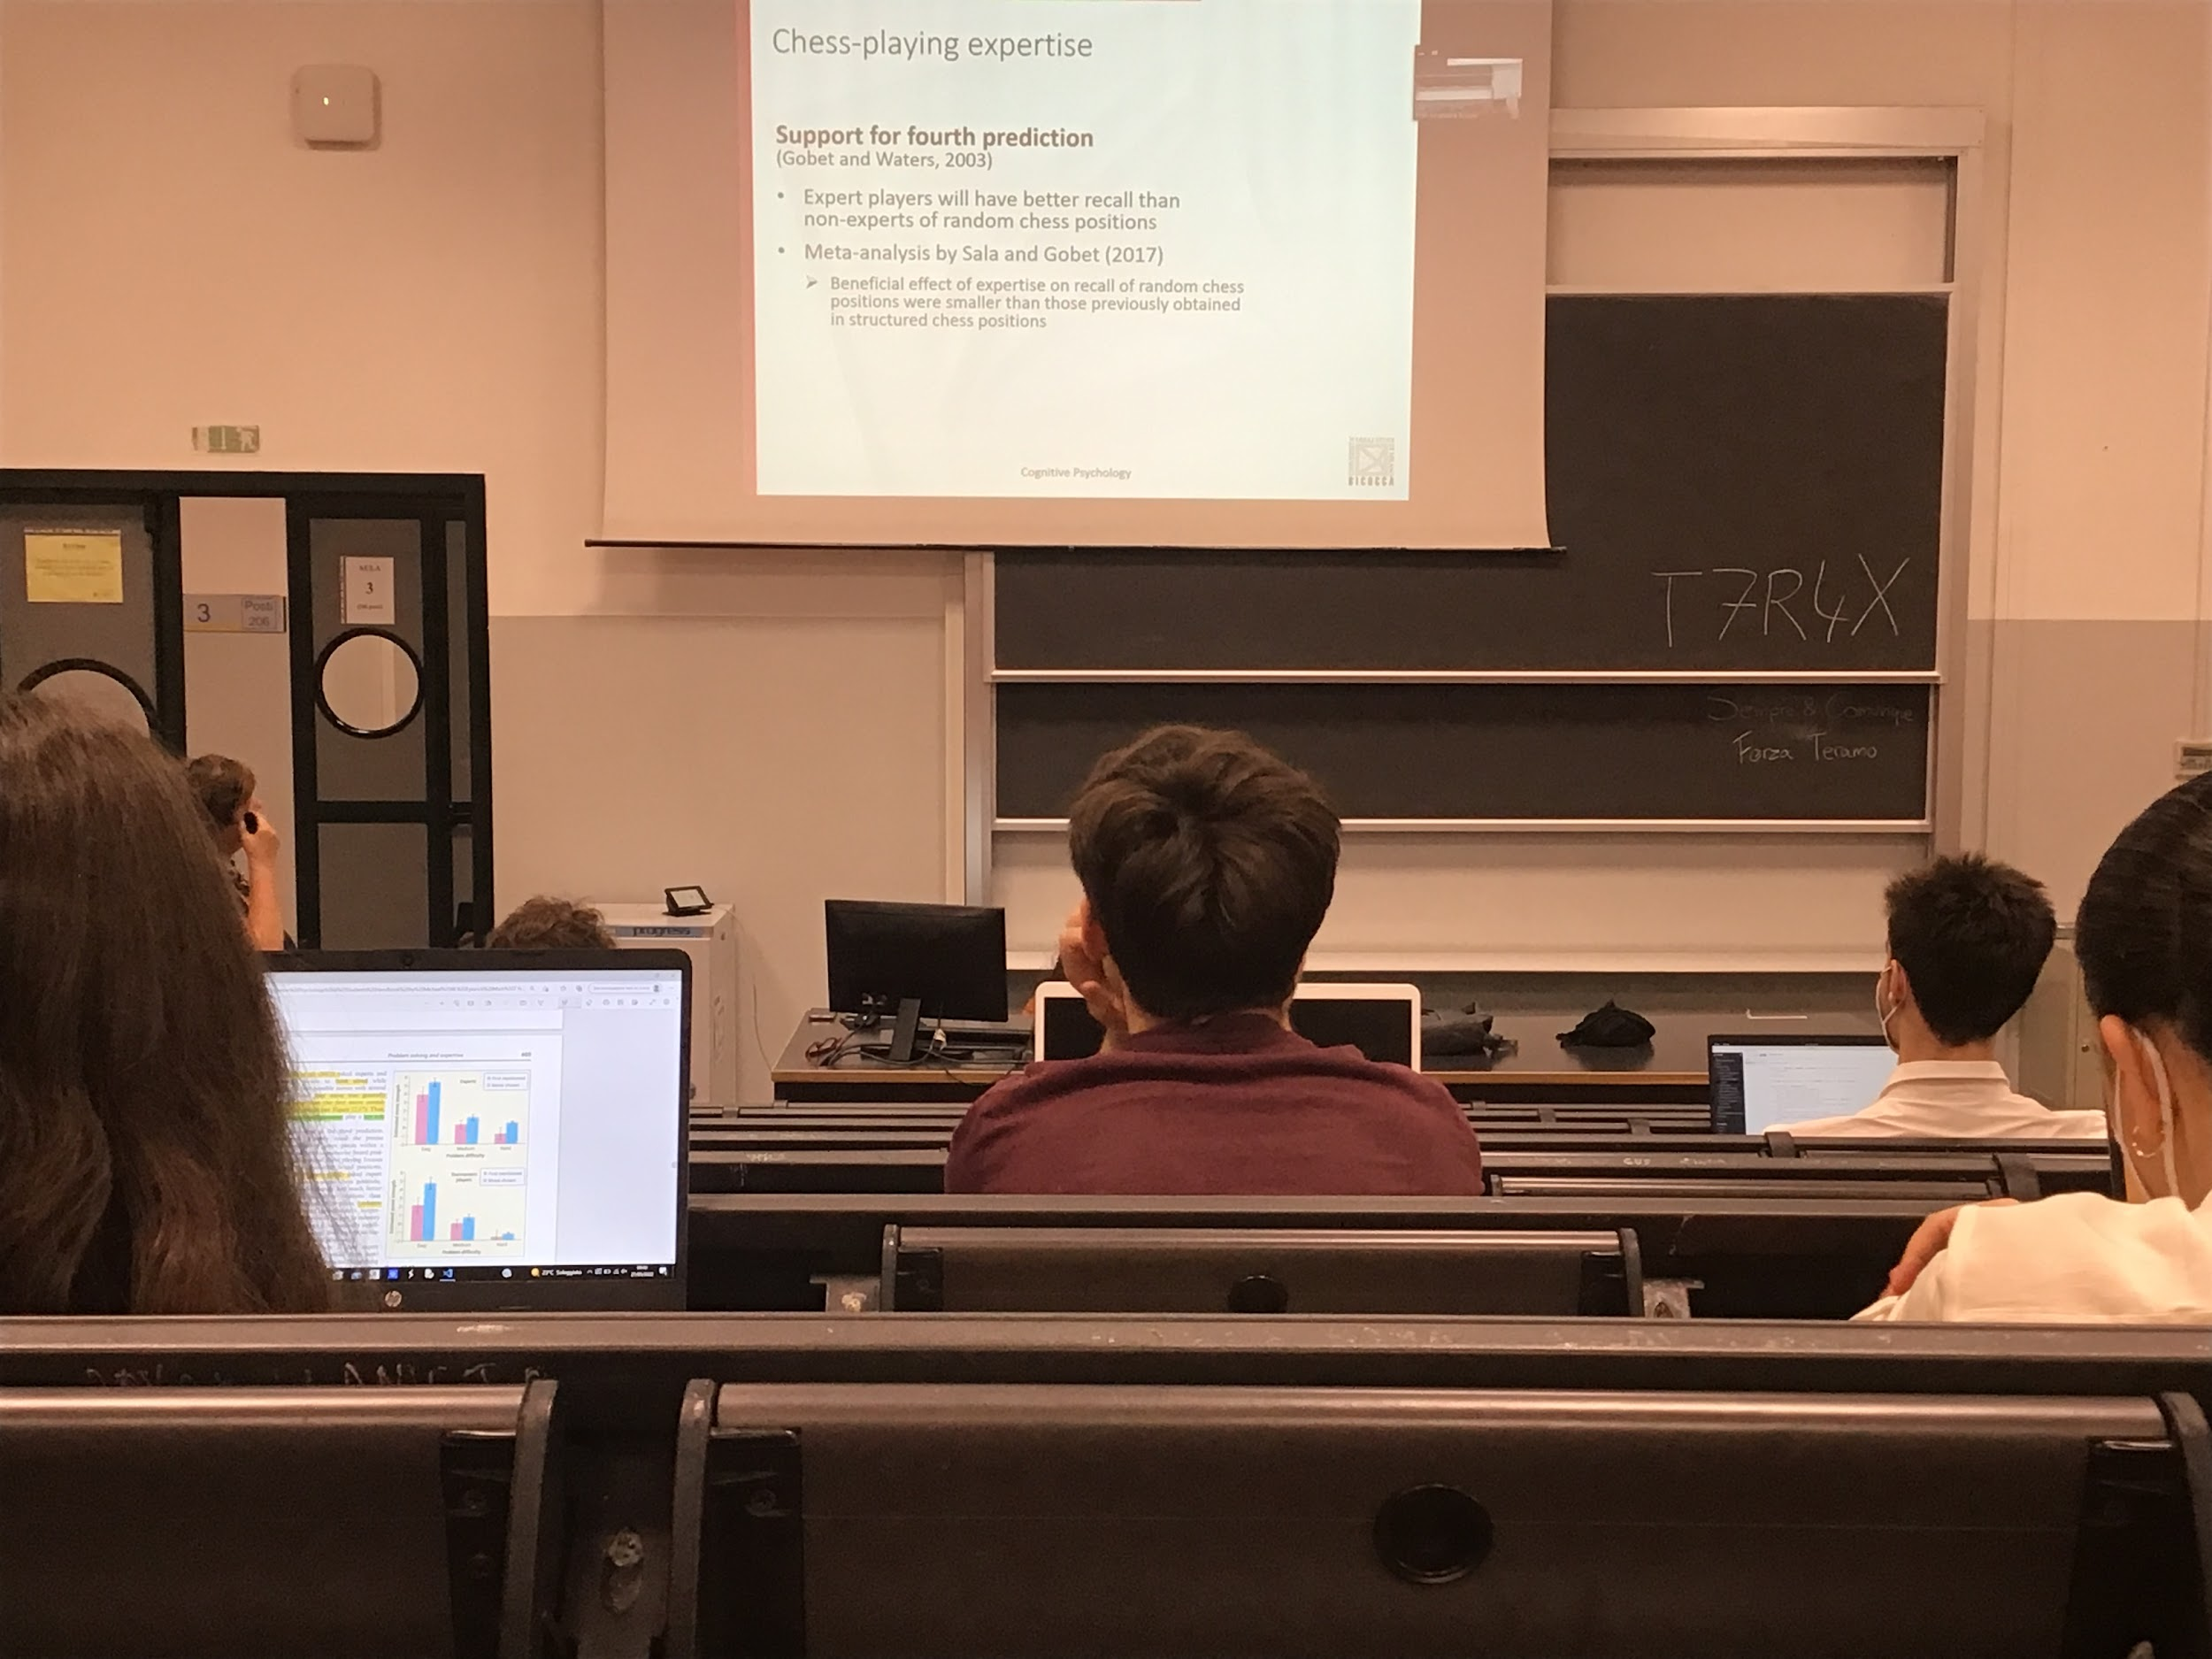

Expert even if they are better at recalling the correct position are still better in collecting random chess positions

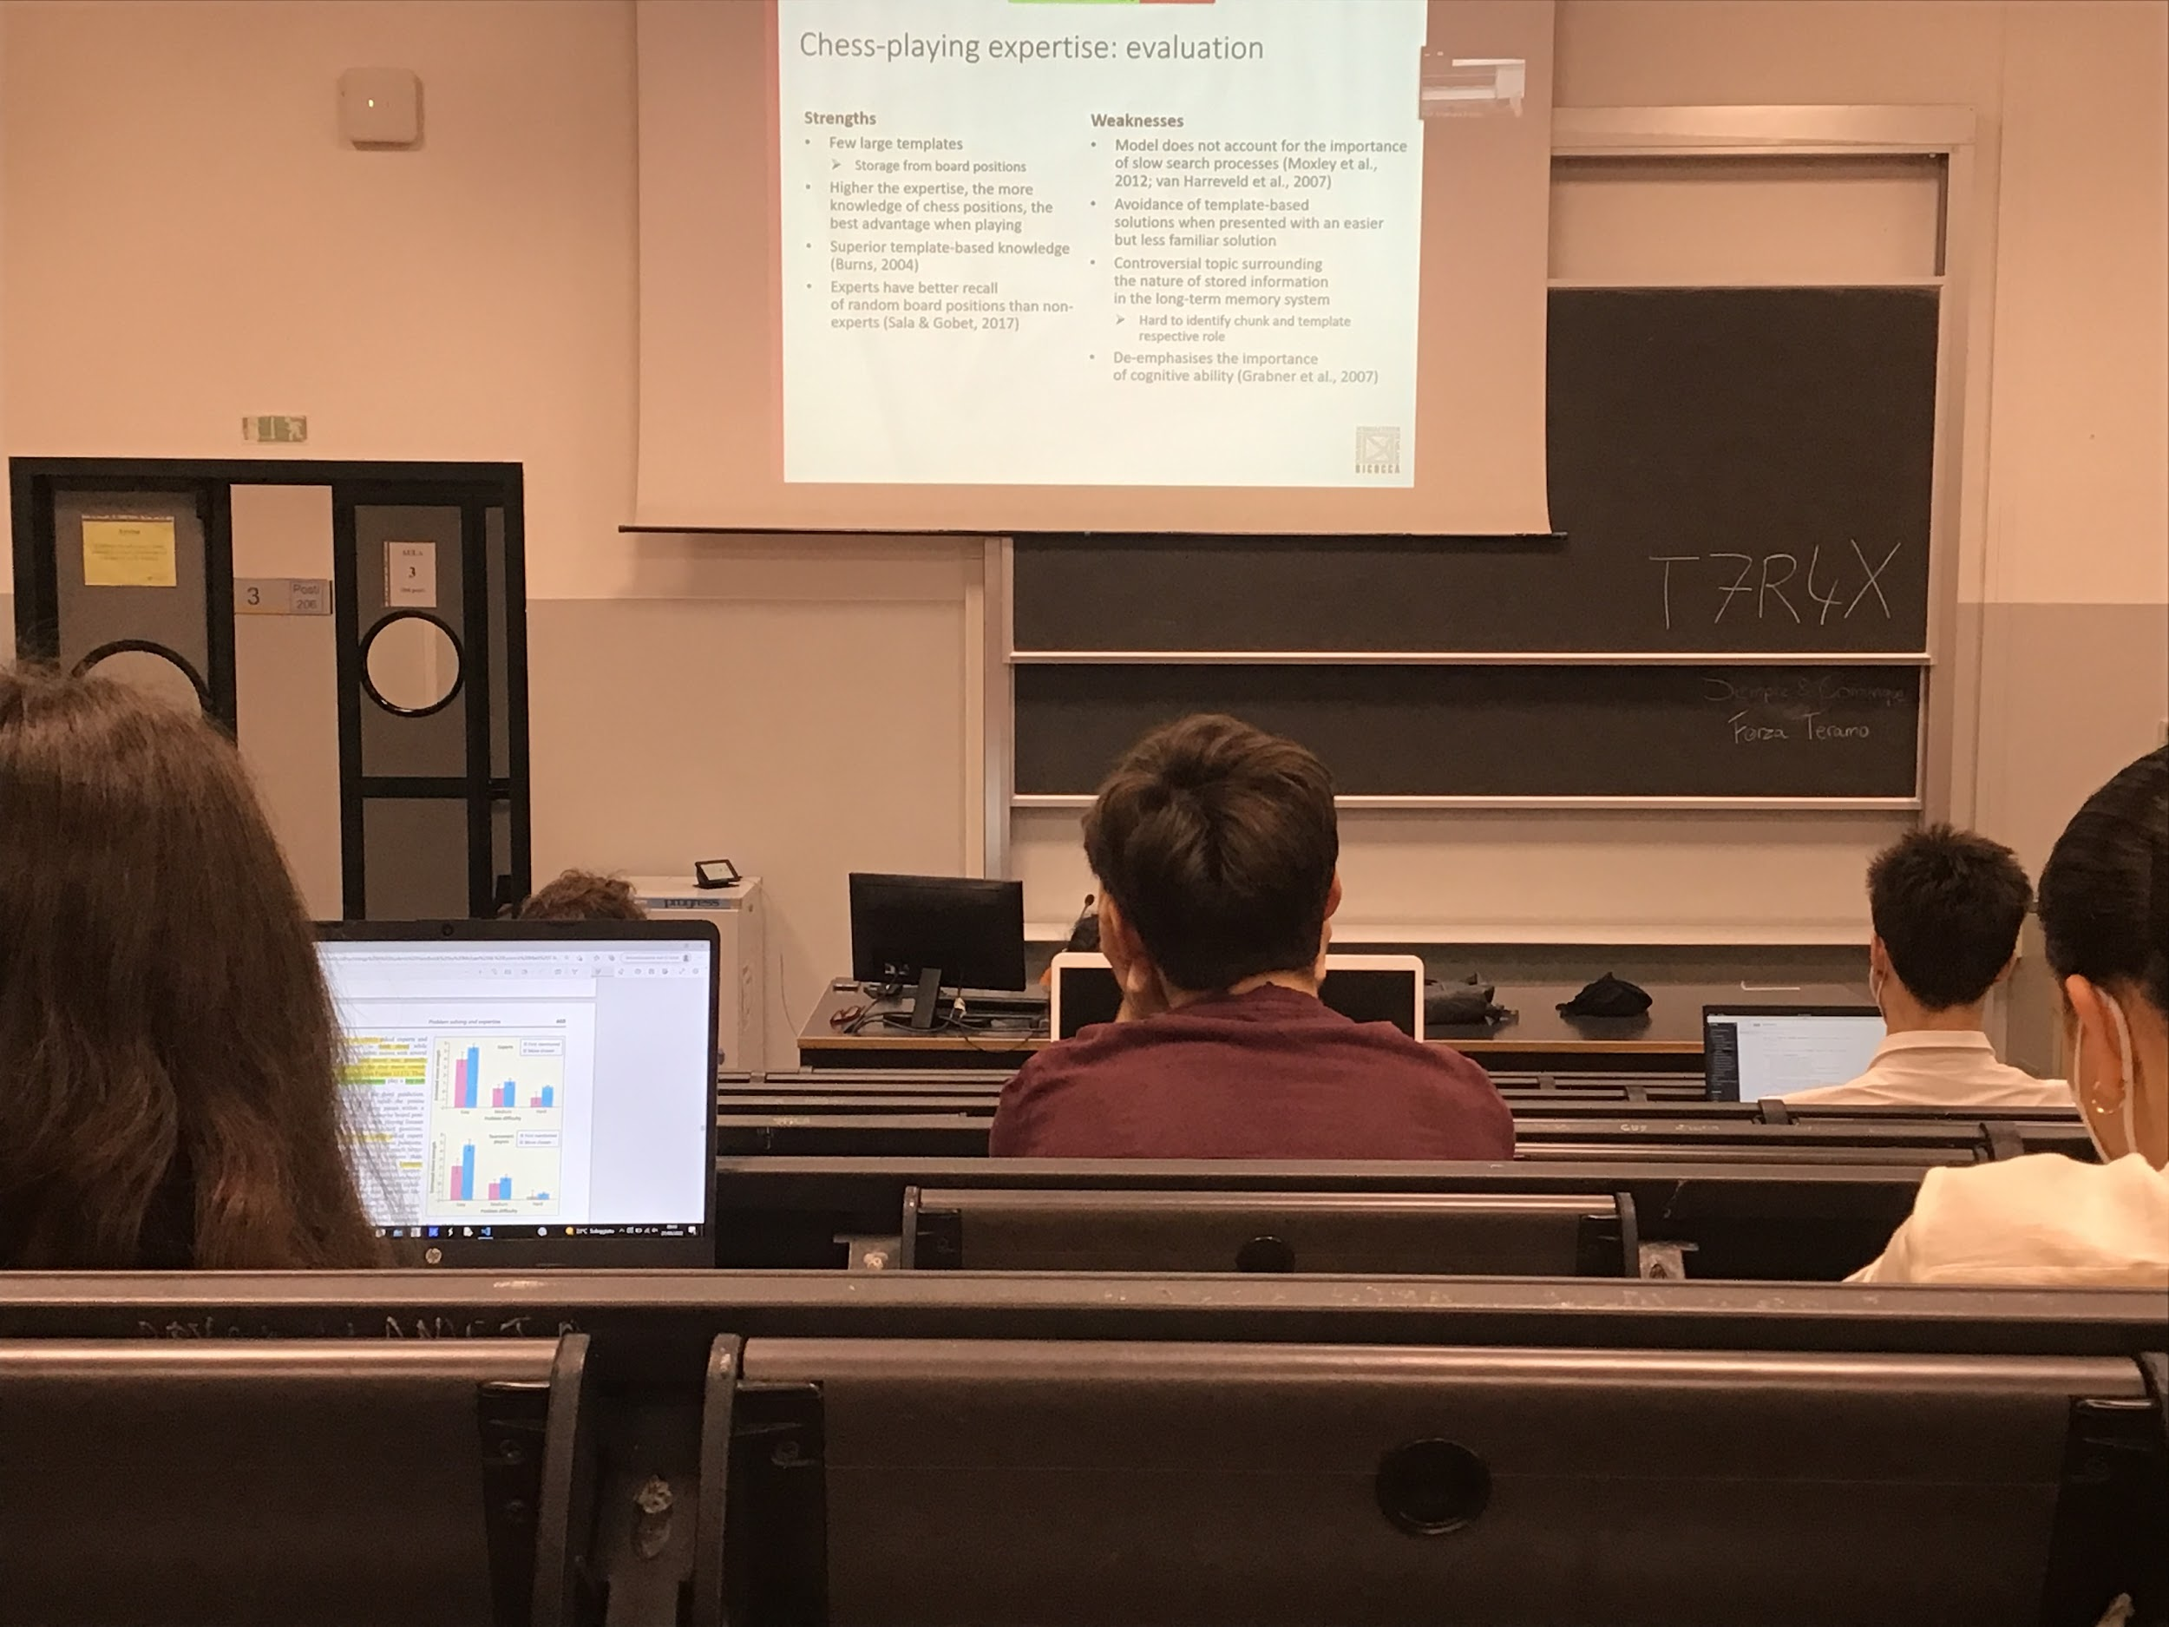

How do experts become experts? They stores few large templates, with experience this template increases in size, can have more potions memorise

On top of that, since you are very good at memorise the template you are better in memorise random position

The template ability is not perfect, the first move that comes in your mind is not always the best one

No data show correlation with cognitive ability

Chess expert are definitely much better then others

People become able to us this information to solve the problem

# Medical expertise



Two ways we study expertise with eye tracking, try to understand where he looks at the position of the tumour

Thinking out loud: sometimes we ask to talk while they are looking around

They do not always find what is there. There are different types of problem

* **Detection errors**: they never looked at that position, there is an area with a tumour and with the eye tracking they never went there
* **Recognition errors**: they actually look there and they do not detect the difference
* **Judgmental error**. They have ad doub, keep looking there and they do not classify as a tumour

Experts make much less errors of non expert

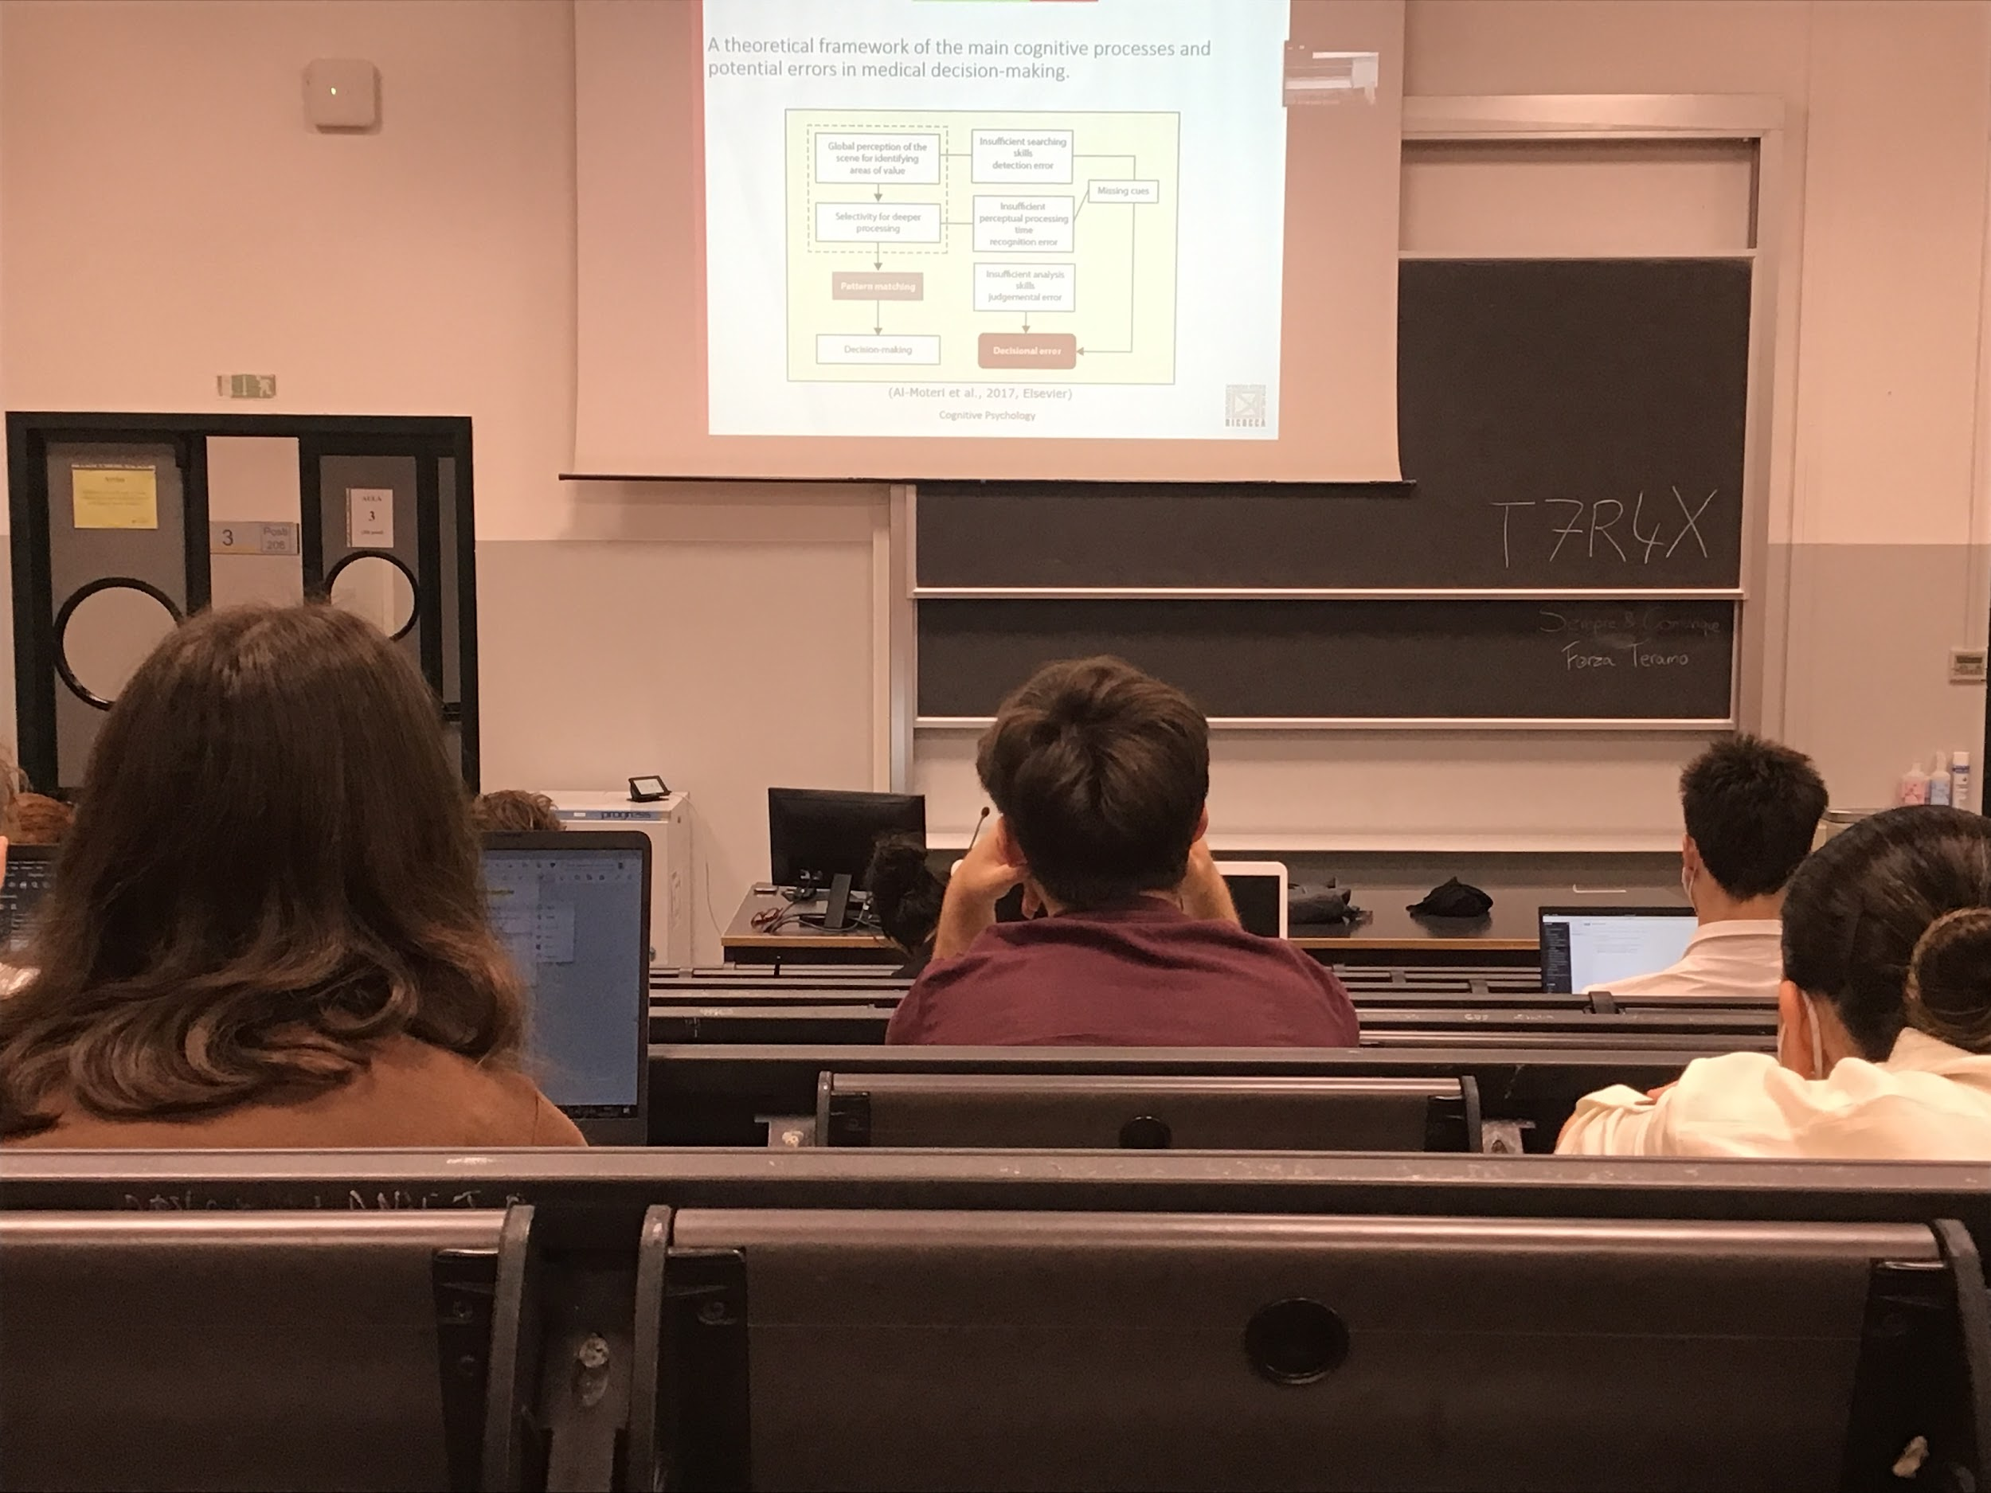

Idea tha errors happen in different steps of the cognitive process that brings to the decision making

A problem in detection error is a problem that people do not search enough, do not scan well enough all images

Problem that is given by the inability to understand where there could be a problem

* Searching skills brings a detection error that inhibits the global perception of the scene.
* Recognition error: when you don’t give enough time to the perceptual system to process what you are looking at, you move your eyes there and you move away very fast

Unable to select the area for deeper processing

* Judgmental error: unable to understand or to classify the specific image as a tumor

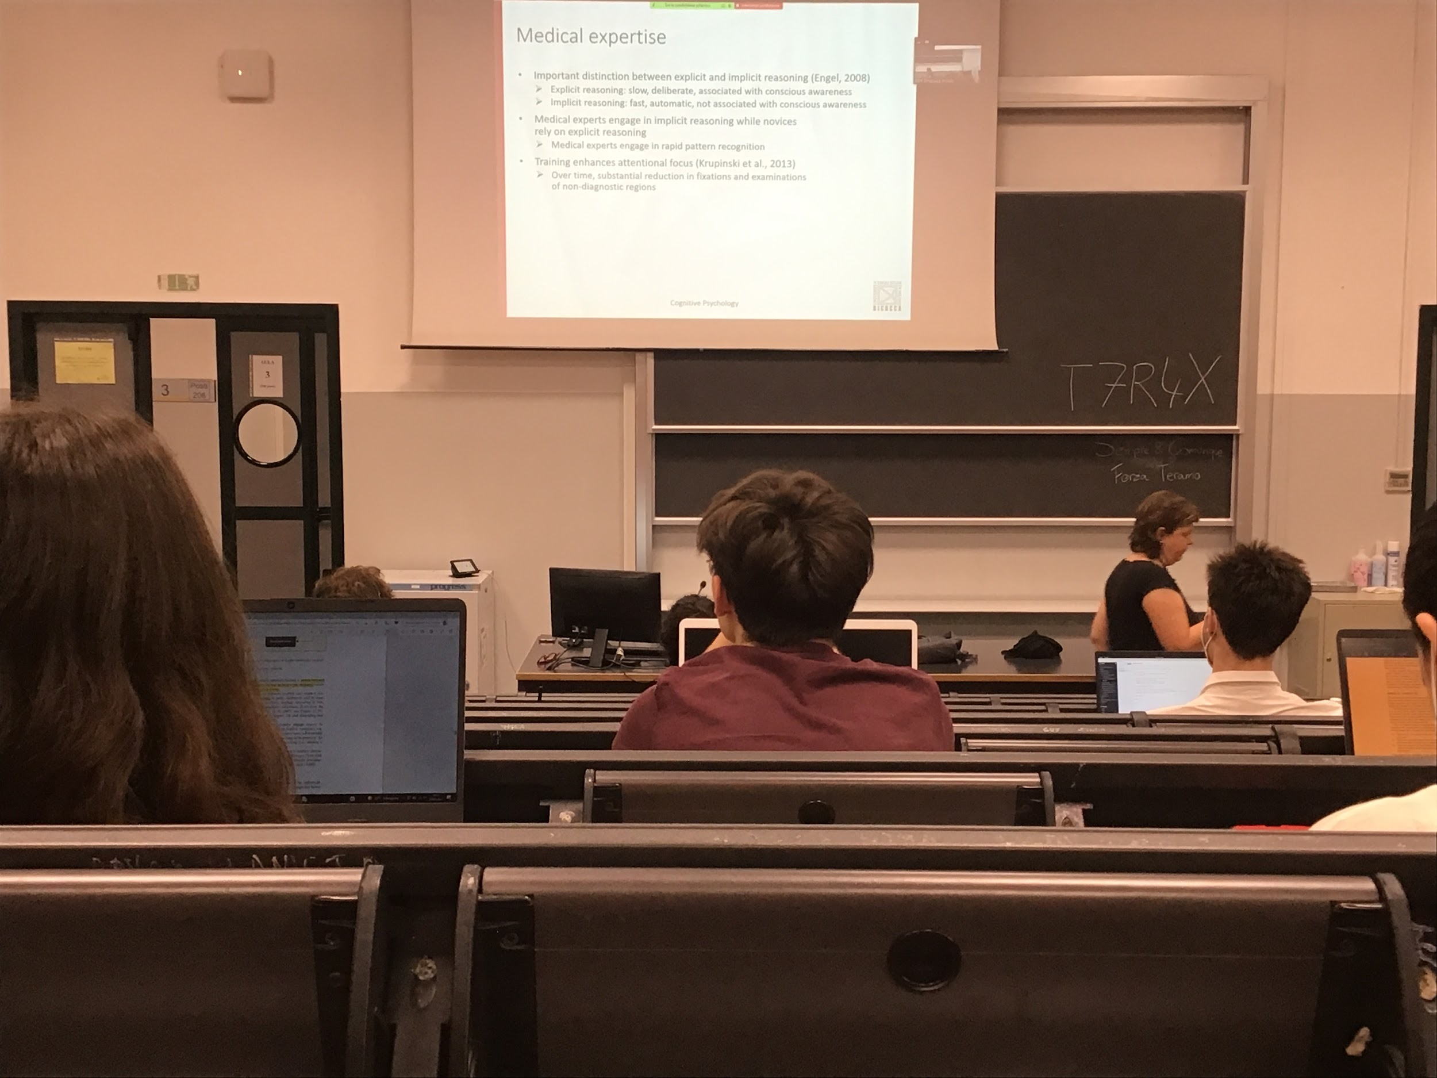

Expert are able to detect the position where the possible tumour is much faster than the novices

Novel students are looking very systematically on each position to try to find where the problem is, while the expert looks straight away to the position where the stimulus is

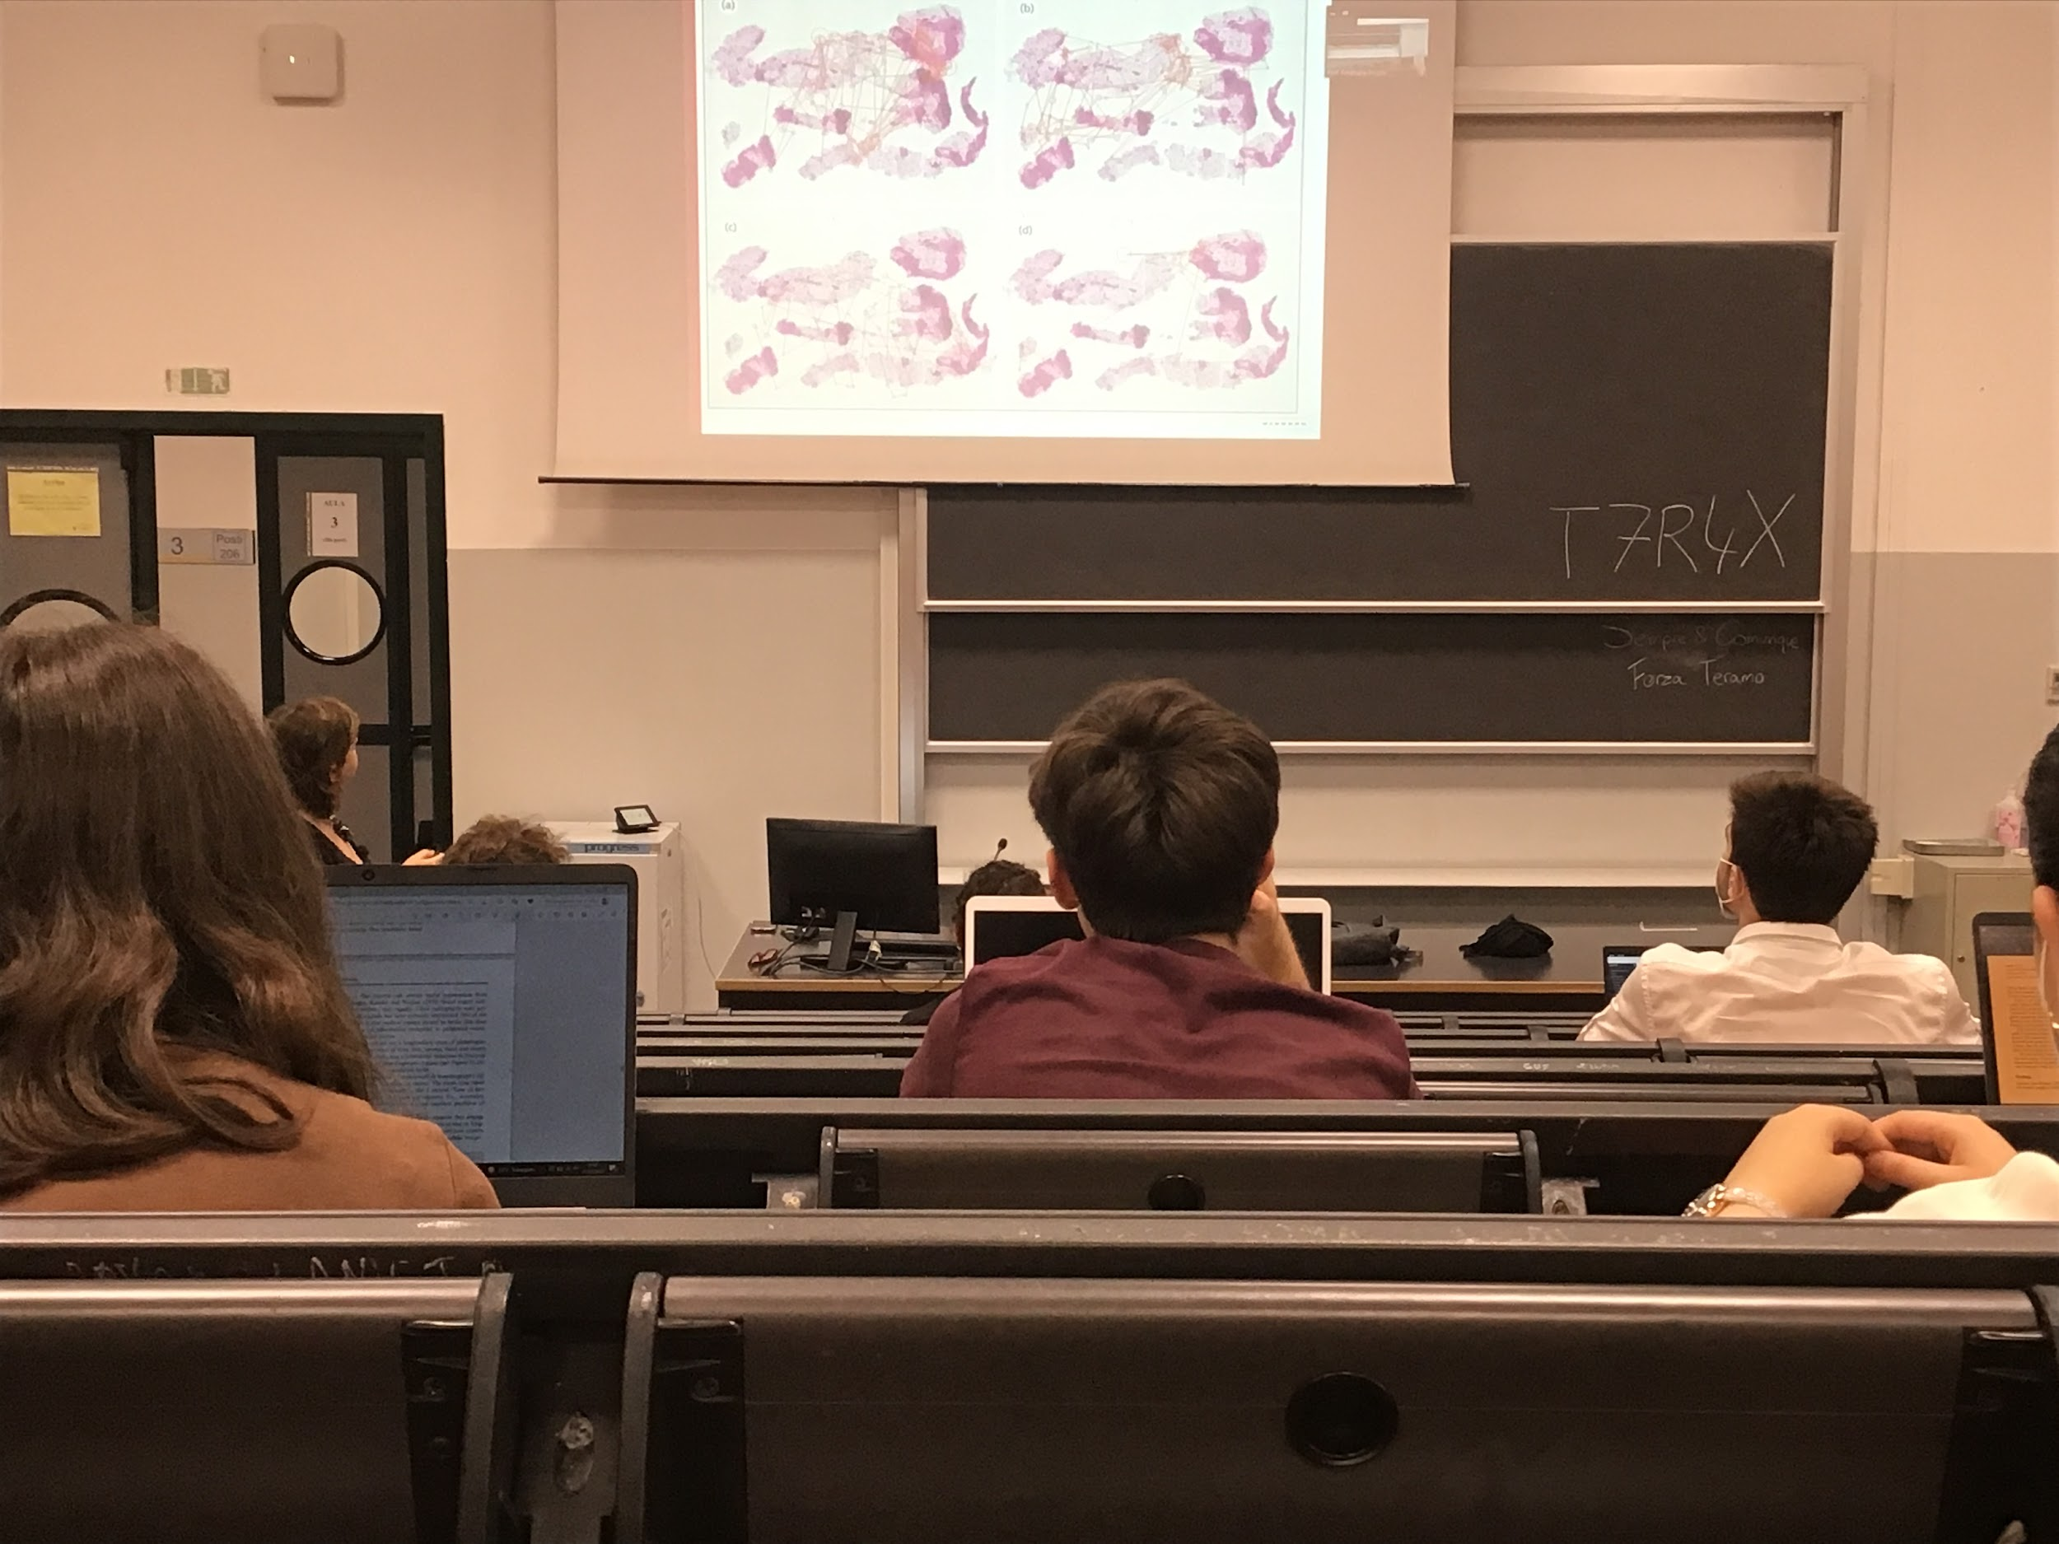

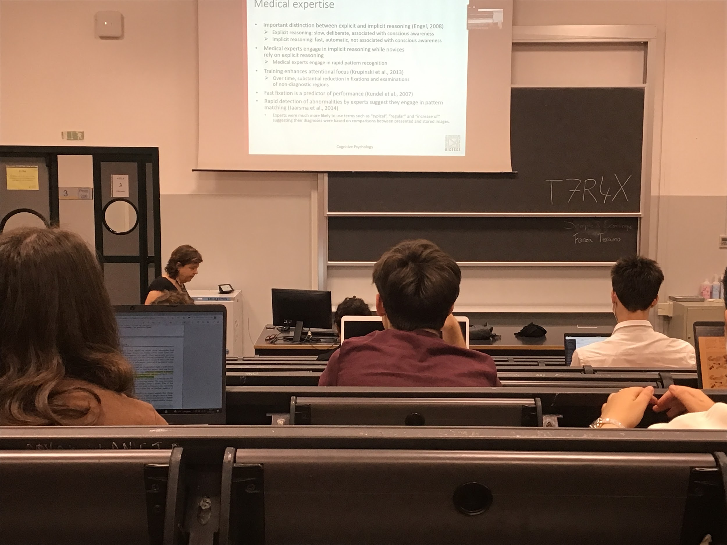

Experiment to see how expertise develops. When you become an expert you go much faster, go directly on the important position

Don’t look t at non important regions

Speed is something that classify the goodness of the programs

There is rapid detection of abnormalities

They create a pattern, remember the psychical structure of the tumour and so they have memorise an image of what the tumour should be

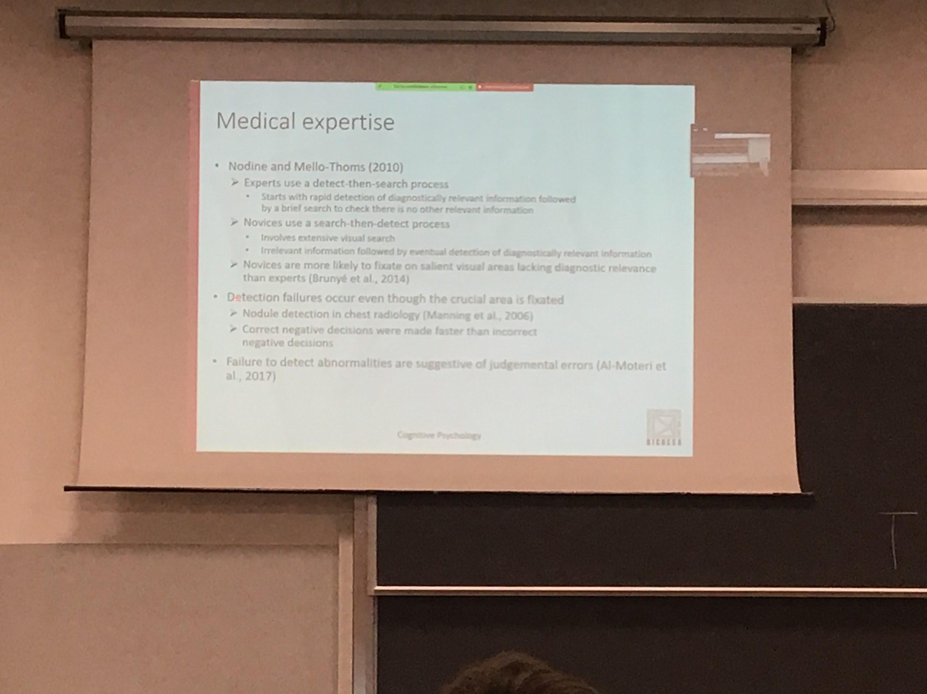

Novices do extend visual search: keep searching and they detect. Exclude all the irrelevant information and then finally they will find the important information

Experts go almost directly on the solution and then they check if there is something else

Novices also look at drakes spaces, larger areas… most of the time those areas are not important for detecting a tumour

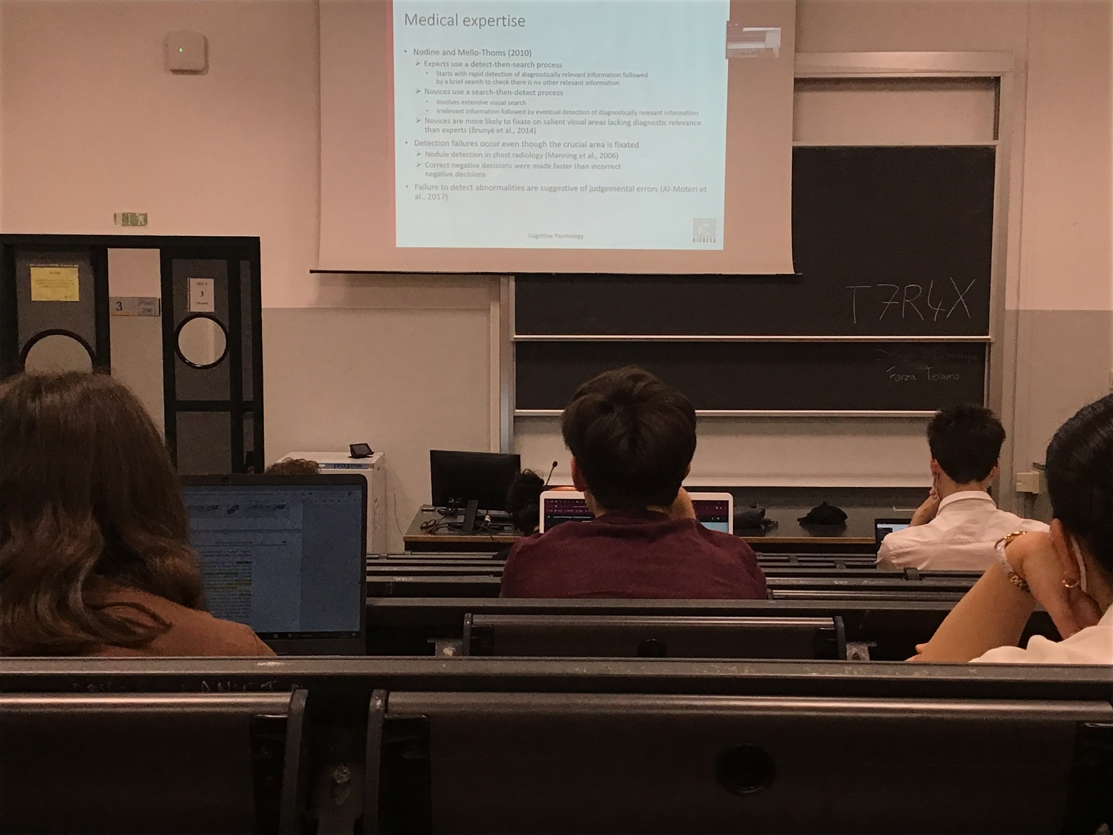

Different ways to become an expert. Using eyes movements even if what we memorise is different

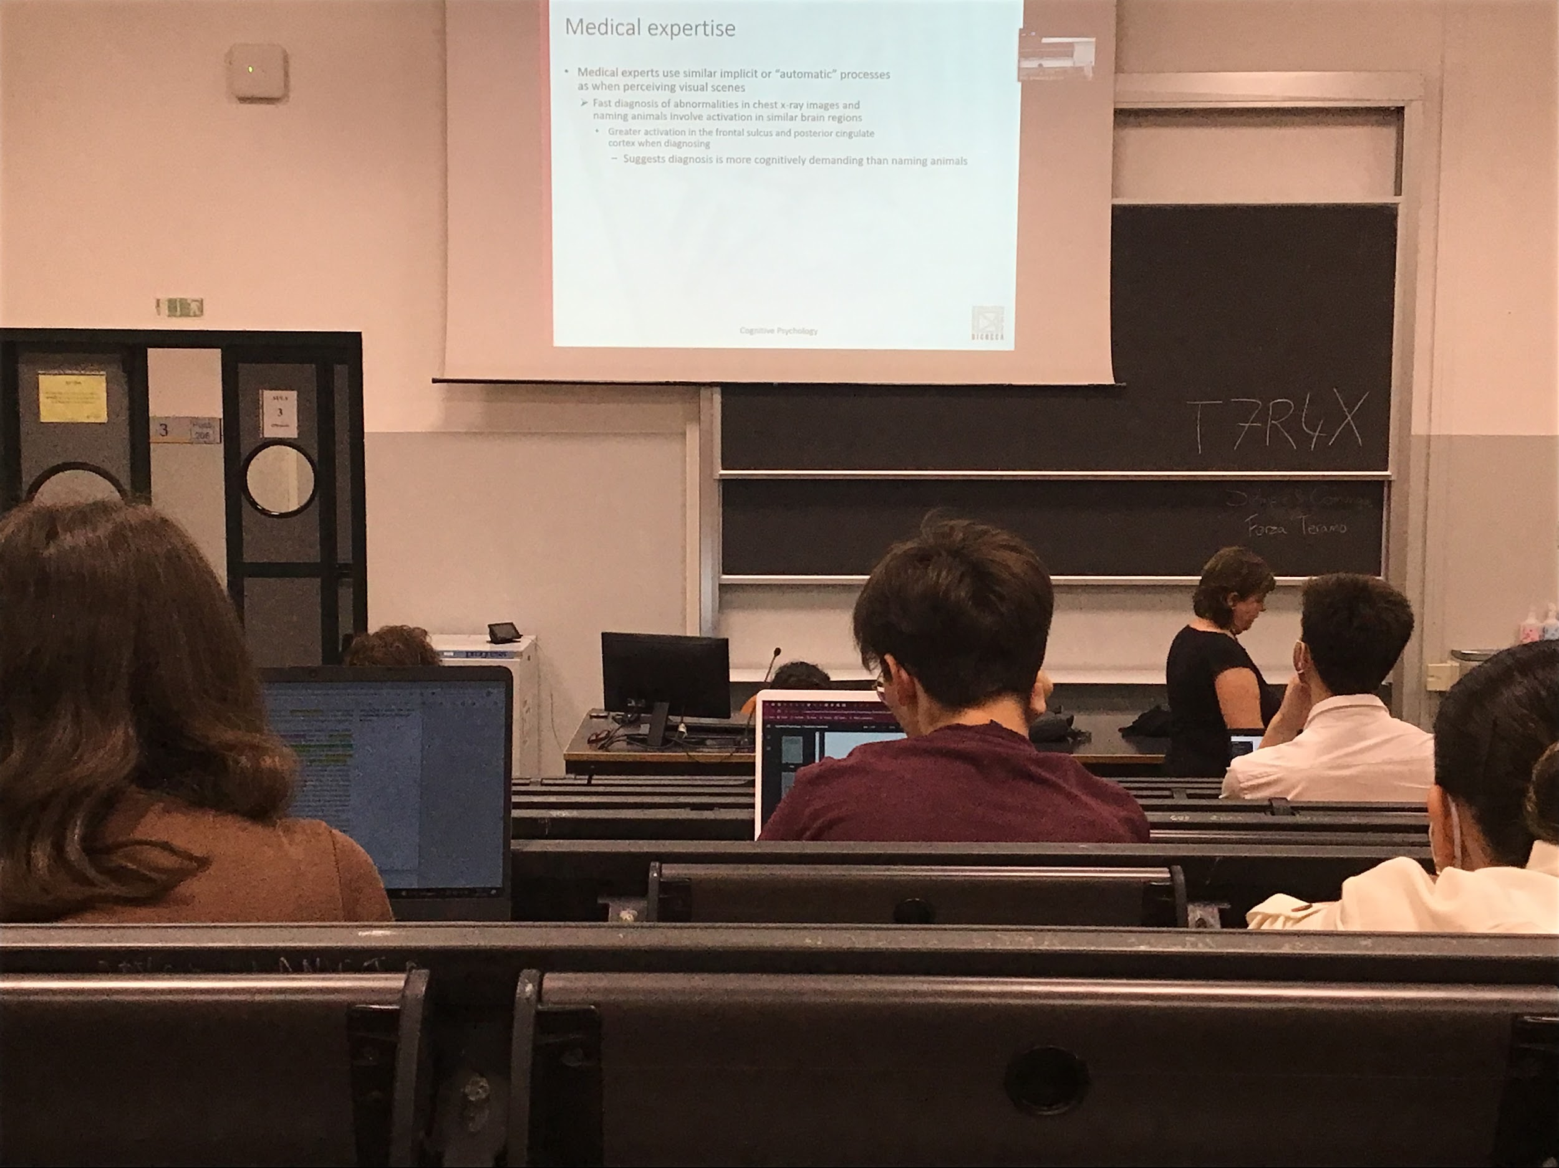

**Medical expert looks only on important position**, they have learn and can automatise the important position

Being expert increase the amount of areas that you are using

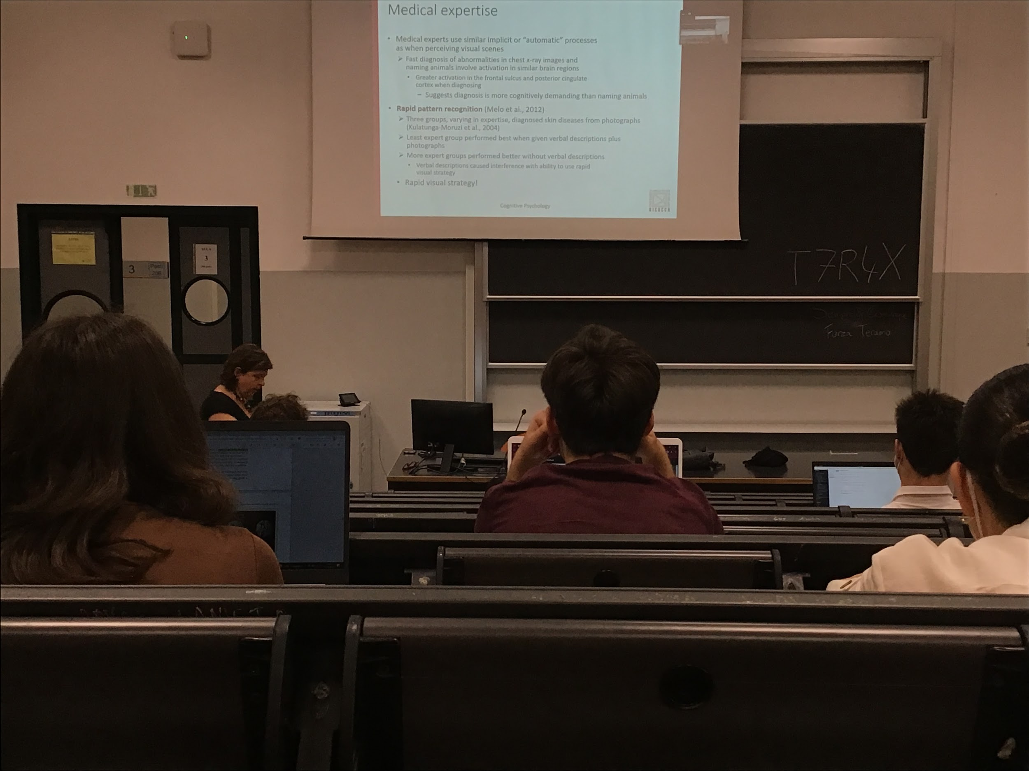

Strong support of rapid visual strategy connected to being expert

Expertimt: 3 groups with different levels of experience. Have to diagnose skin disease. Can look at the image and the description

**Most expert group did much better without the description that they took attention way, least expert group description helped them**

Visual strategies used by expert is very strong and does not need to get interference from other description

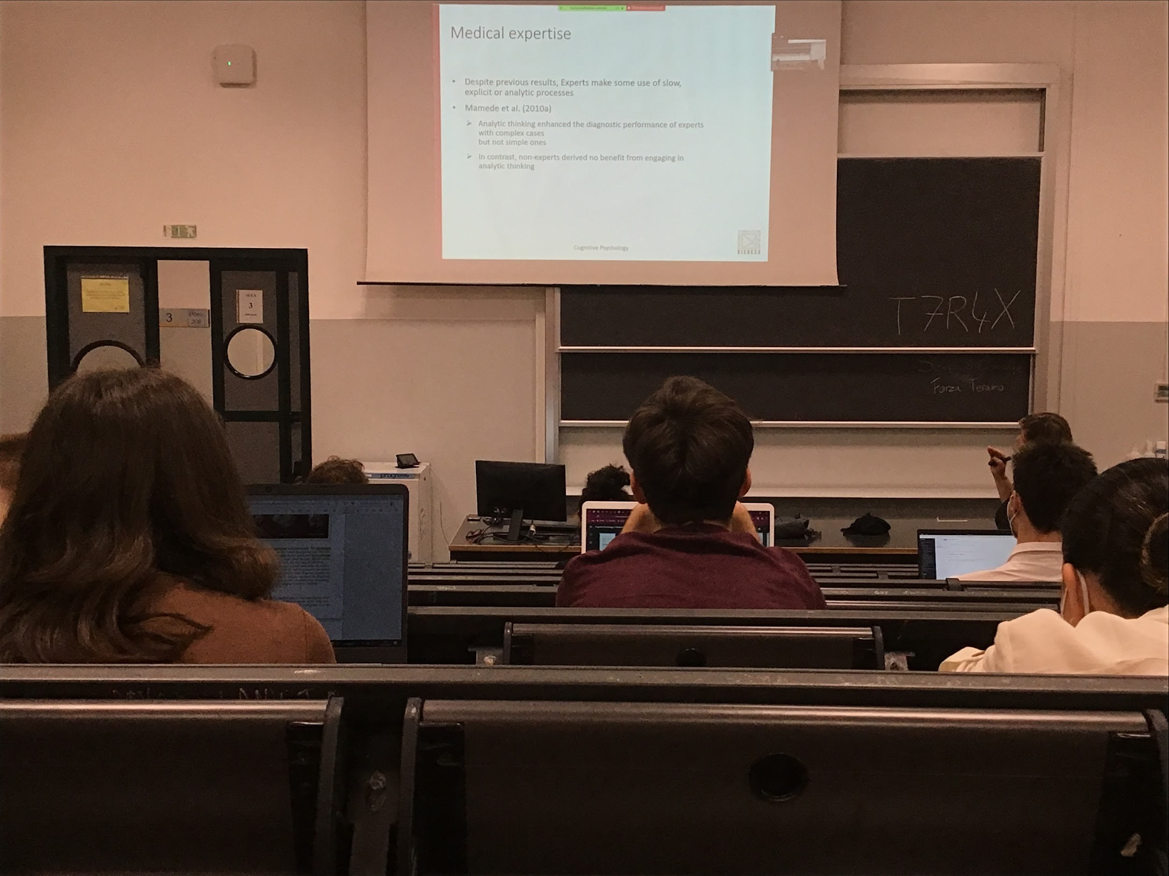

Being able and fast in something does not mean they don’t use slow processes. Can choose which way to use depending on the complexity

In the image is in some way familiar they use implicit processes, but when they realise they can not process fast they go back to analytical thinking

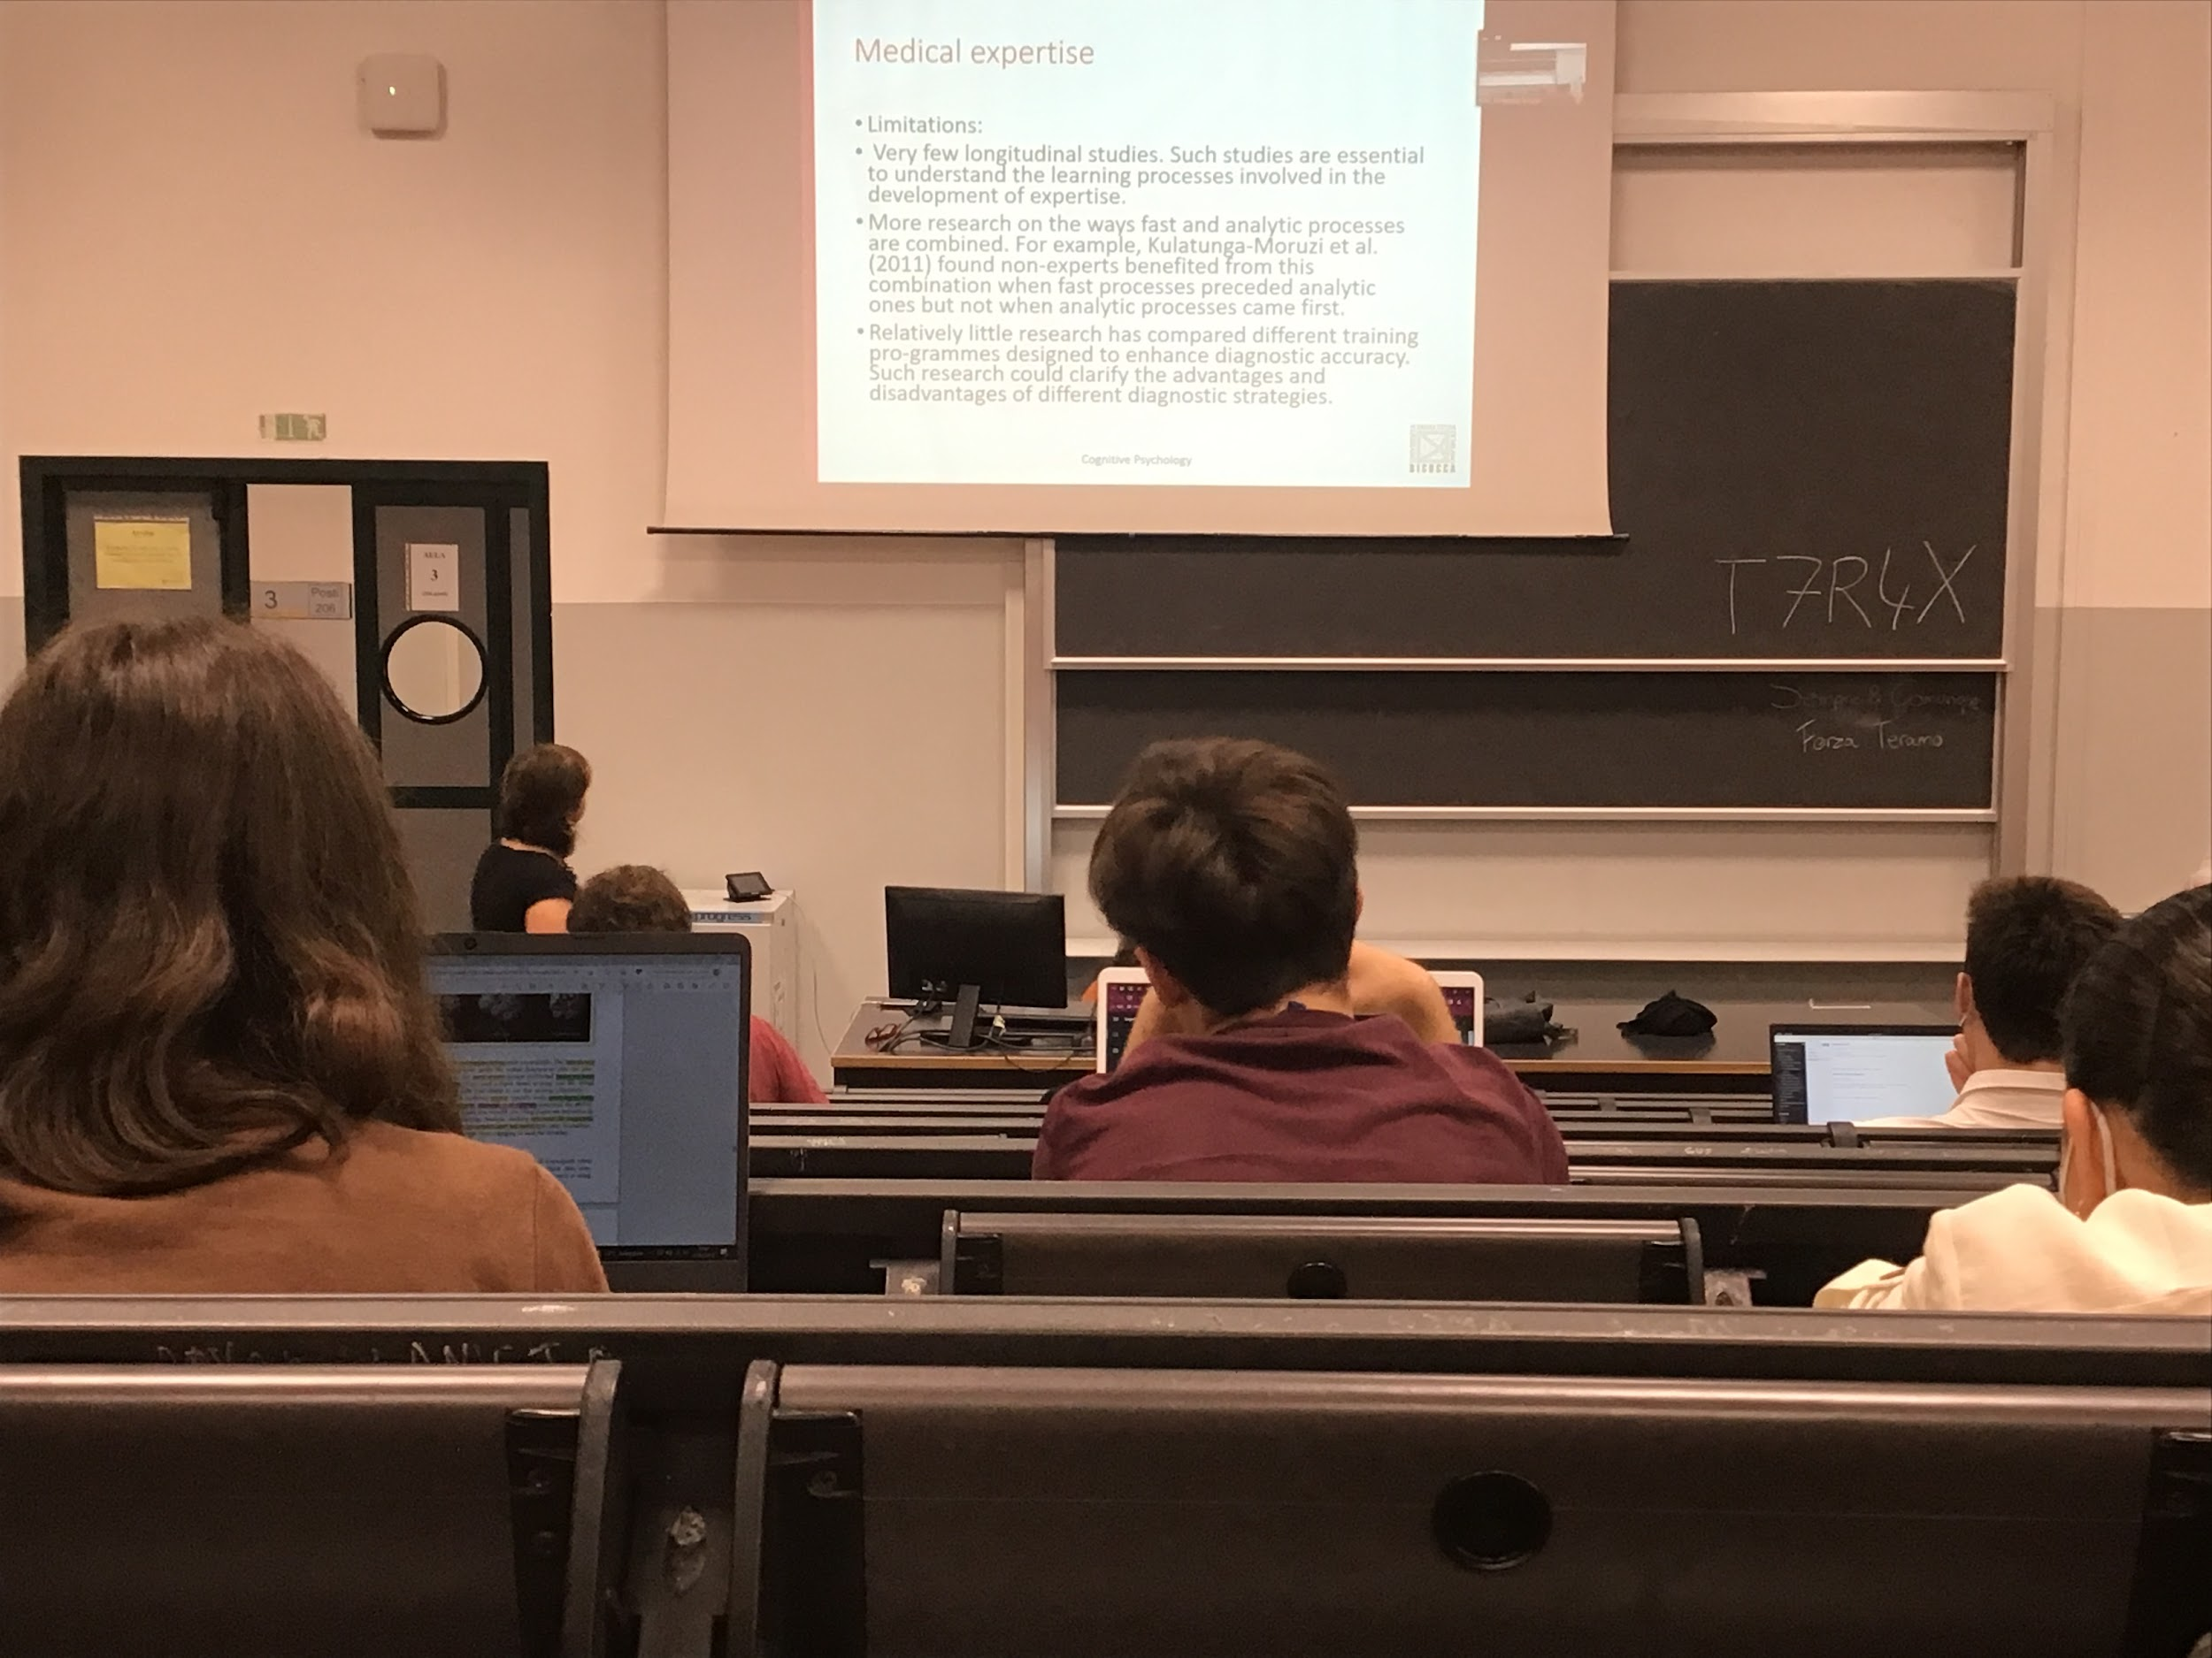

Expert uses both fast and analytic process, don’t know how they choose one instead of the other

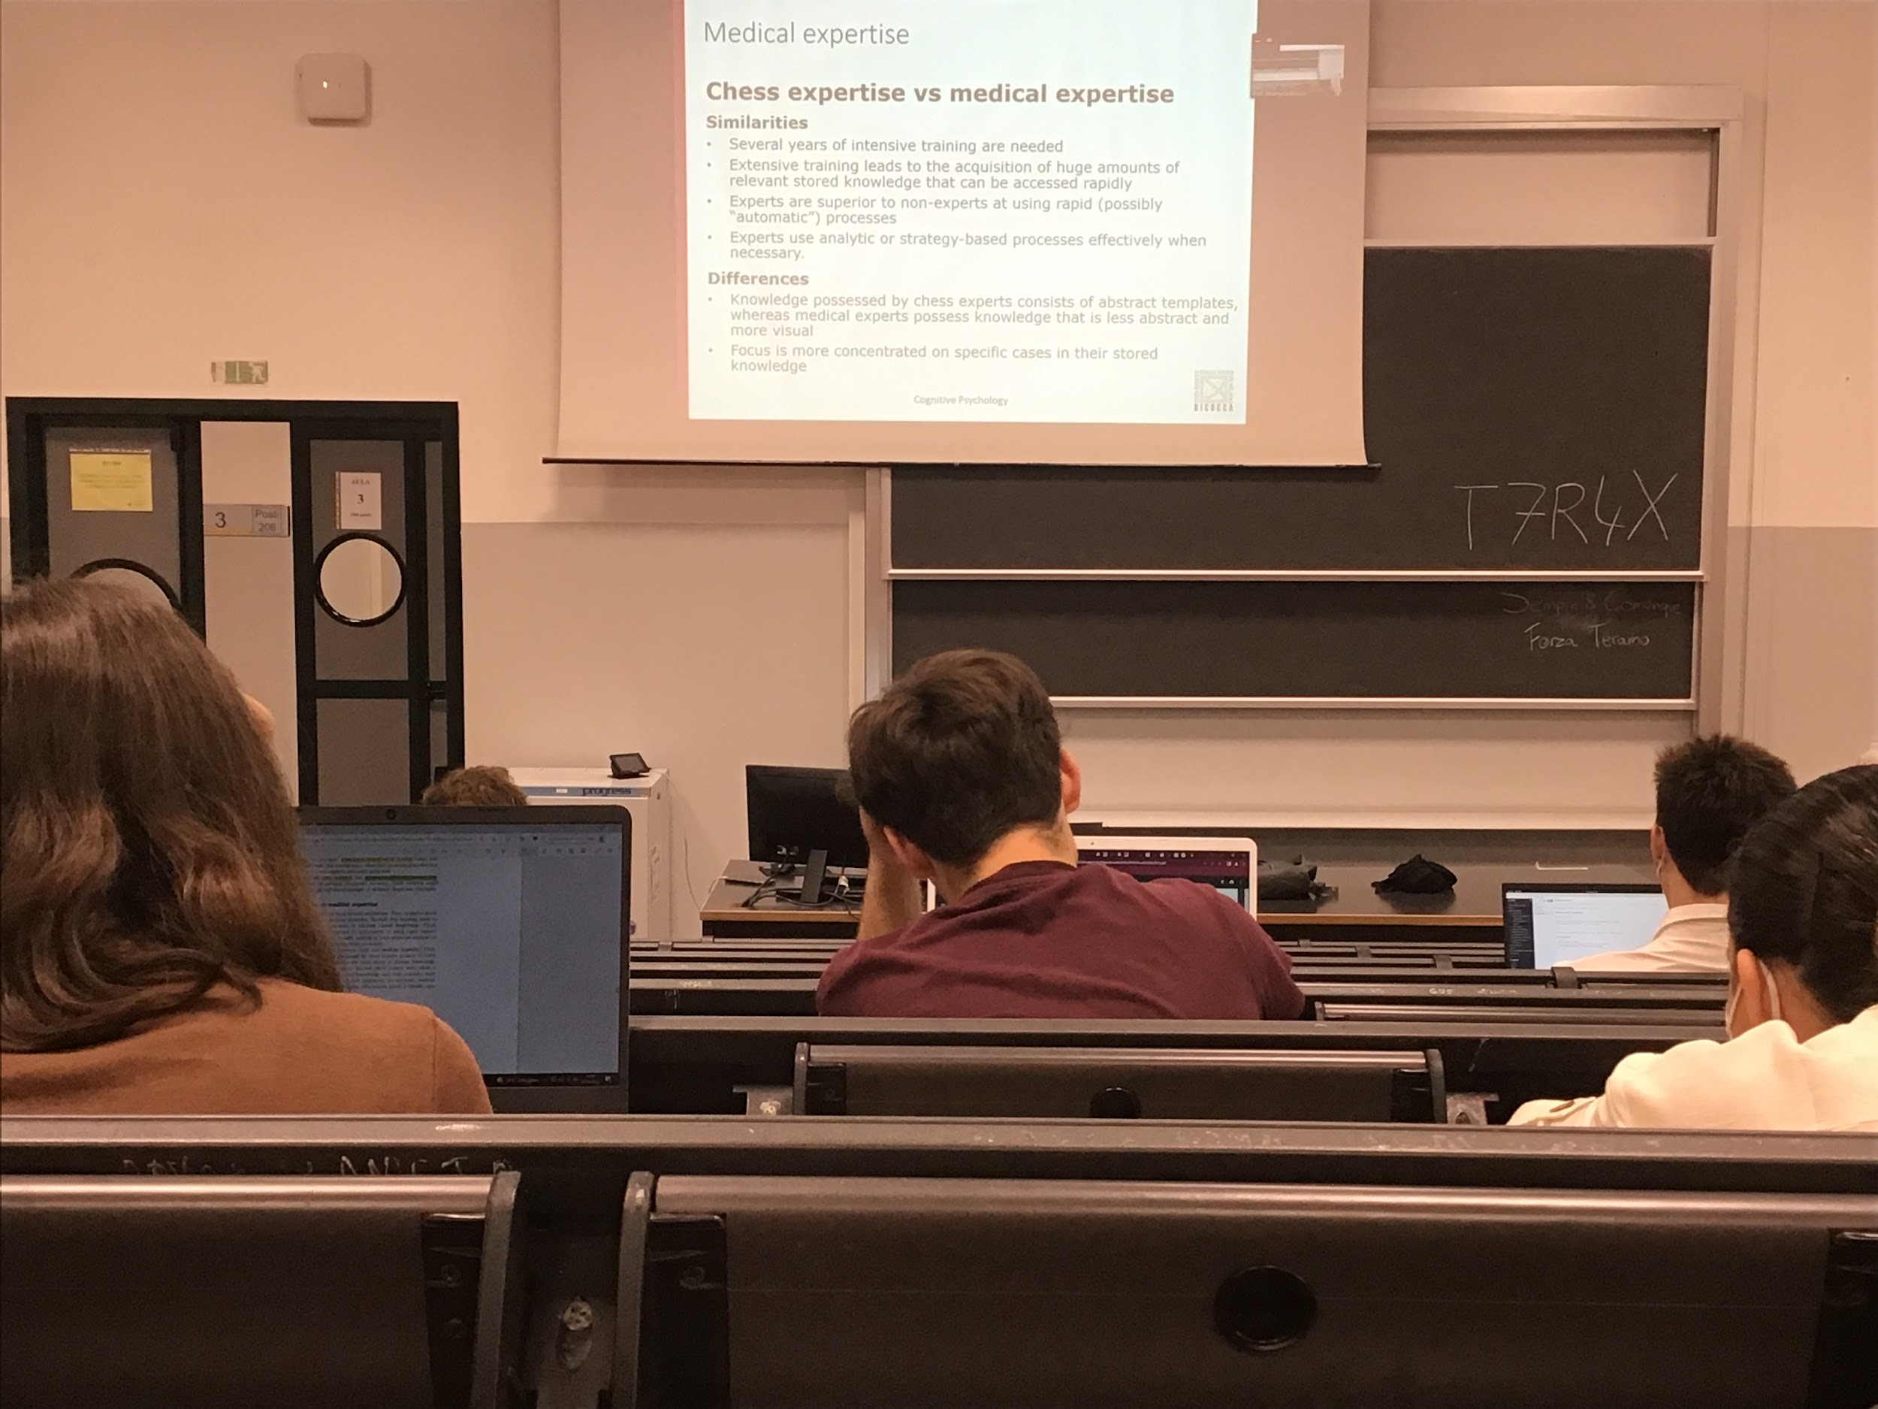

Both need a lot of training. Incredible amount of knowledge that is stored and that can be accessed rapidly. **Experts are better at using rapid processing but also choosing to use analytic processing when necessary**

Difference; type of knowledge they store in one case is template and one case is more visual

AUDIO 2

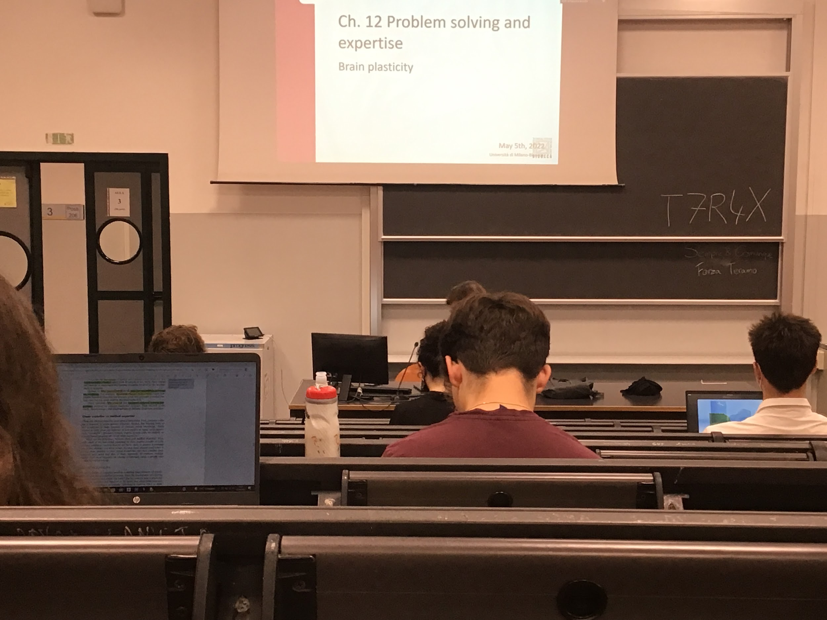

Increase activity in areas in which we do classification

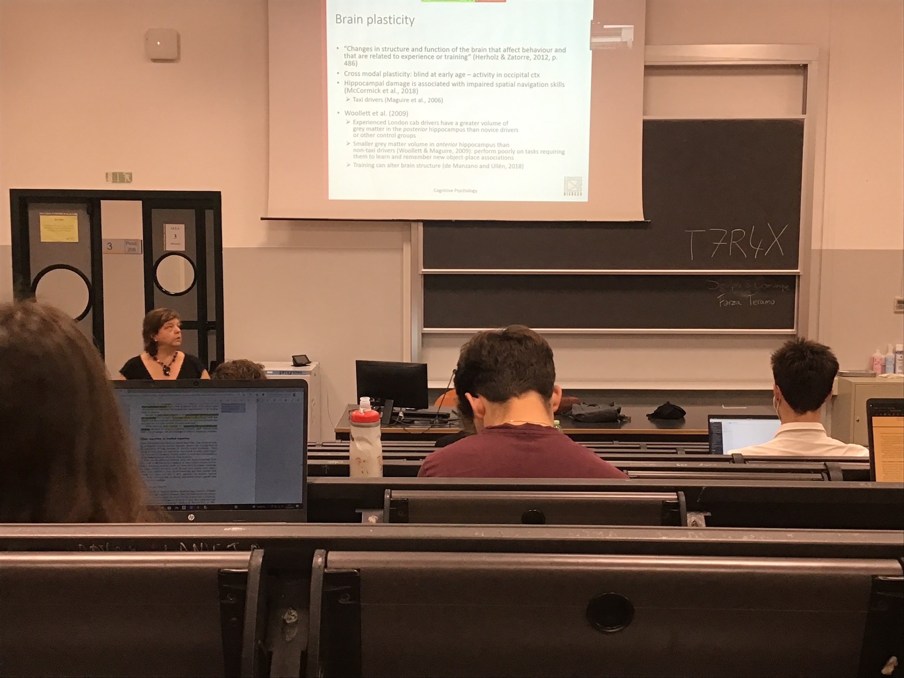

In the initial phase the brain is very plastic

It is not actually the code

Brain changes and we become expert

Different brain areas with dedicated processes. Occipital area dedicated to the analysis of visual information

In the brain there is also when we are young the cross model if you become blind at young age you occipital area is used for other thing (like navigation) even if it is not stipulated by vision

The type of expert that area analysed are taxi-drivers

Taxi-drivers in London have to know lots of different roads. Some of them were able to have “the knowledge” knowing each street of London and how to get there

If a taxi driver have “the knowledge” and hippocampus brain damage can not navigate as usual

If you look at the development of the hippocampus with expert people in navigation, have a greater volume of the posterior part of the hippocampus

The conclusion is that training and becoming expertise can alter the structure of the brain

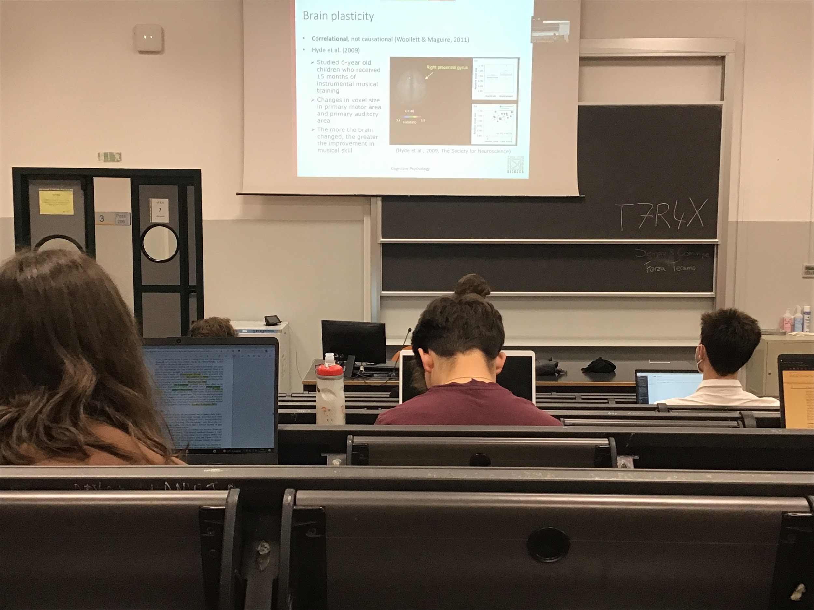

Correlation: don’t know if having a larger hippocampus can make you become a better taxi driver.

There are some data that show that some practice increase some brain areas

Brain areas dedicated to the movement they have learned have occupied more space in the brain. More areas dedicated to that instrument

The experience changes your brain structure

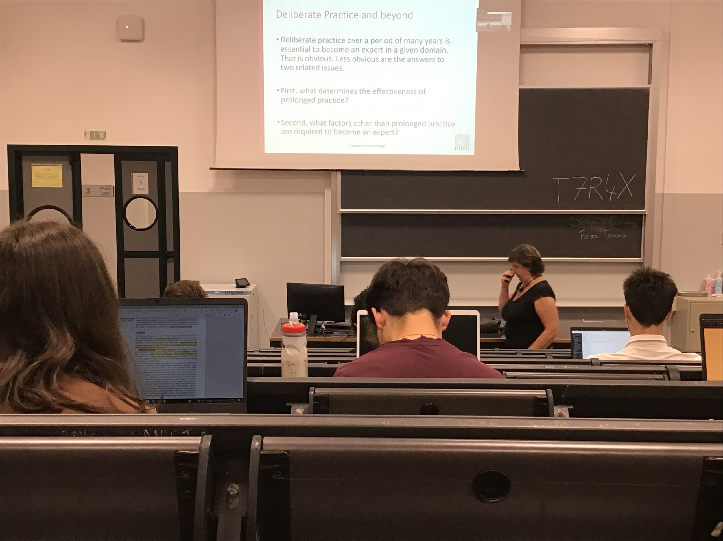

To become an expert we need to do practice. How can this practice be effective? And can we become experts if we do practice?

Do I need to have a predisposition to one thin

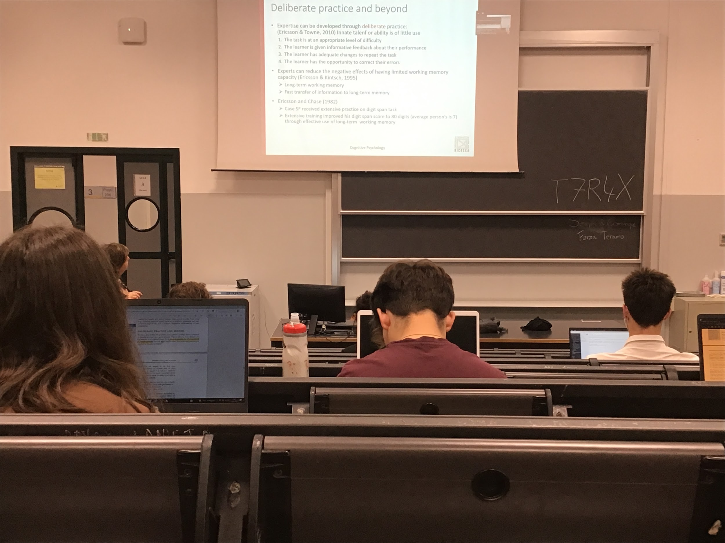

Practice is necessary

Have to do some specific kind of practise (neither too easy and no too hard)

Continuous feedback about your performance otherwise you make mistakes

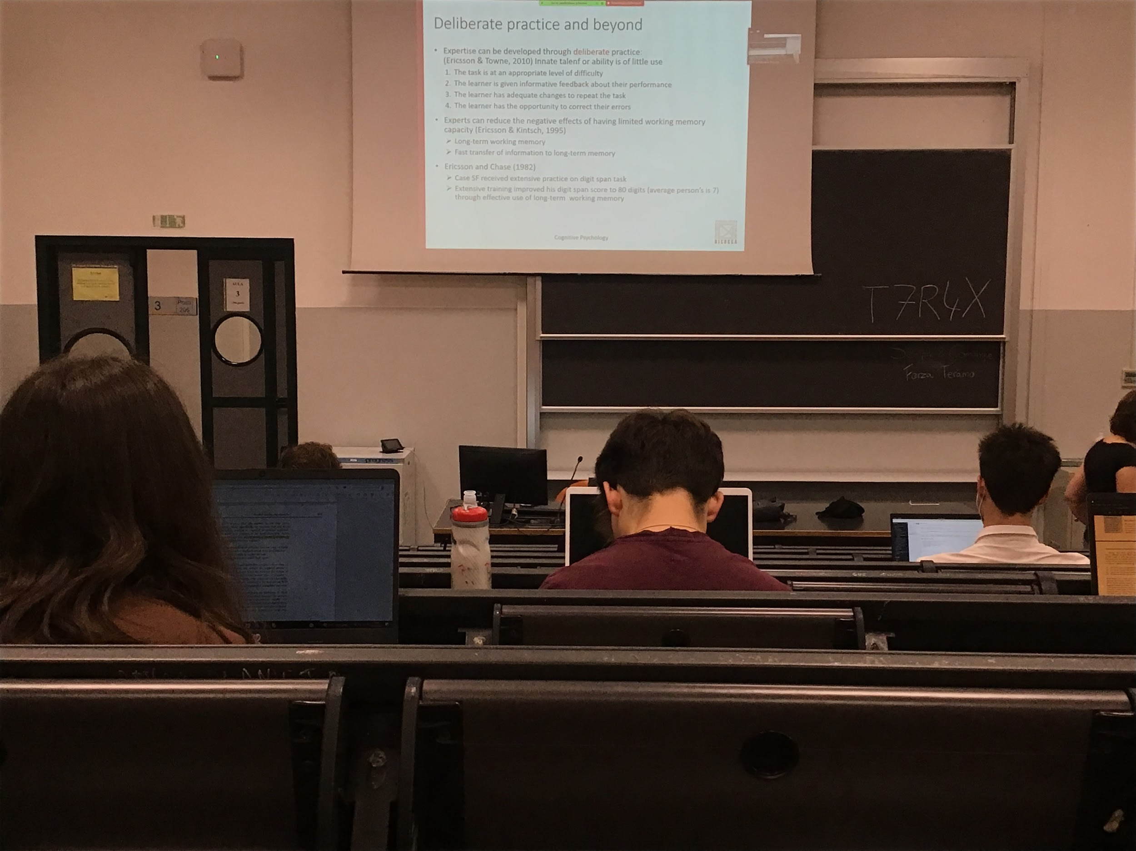

If you do the correct practice you can become everything you want. Not true

Other try to study why some people becomes expert and some no

You are able to use LTM to expand your working memory (it has a limited storage, Can not do complex reasoning and processing) experts learn to use LTM and faster access at retrieving in a way to end their working memory and work better

You can teach people to use in fast way LTM to improve your performance

They try to show using, practice enable to learn 80 digits

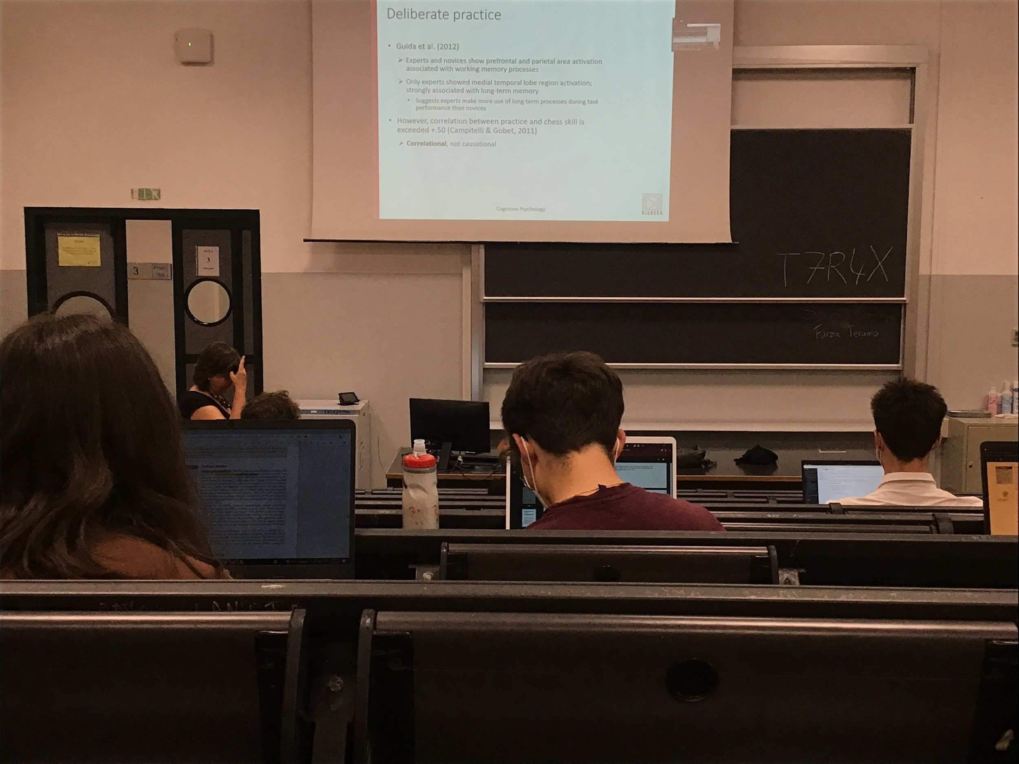

Experts use optimally LTM as a support for working memory. Supported by data of brain activation, show that **when expert do some task they use the medial temporal lobe region**

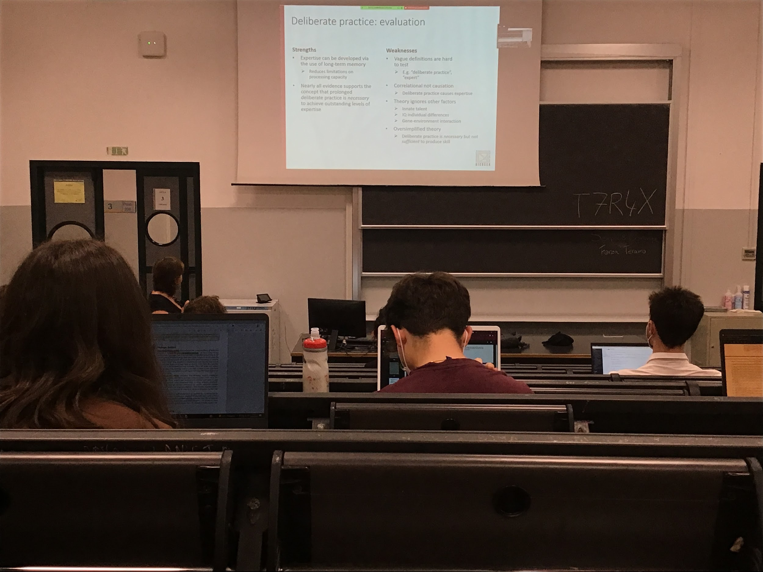

Need to be able to access LTM faster to reduce the limitation of our working memory. A lot of data support the idea that you become expert only if you practice

**Practice is necessary but not sufficient**. Some people do become expert in a file, some even if you try a lot you will never become

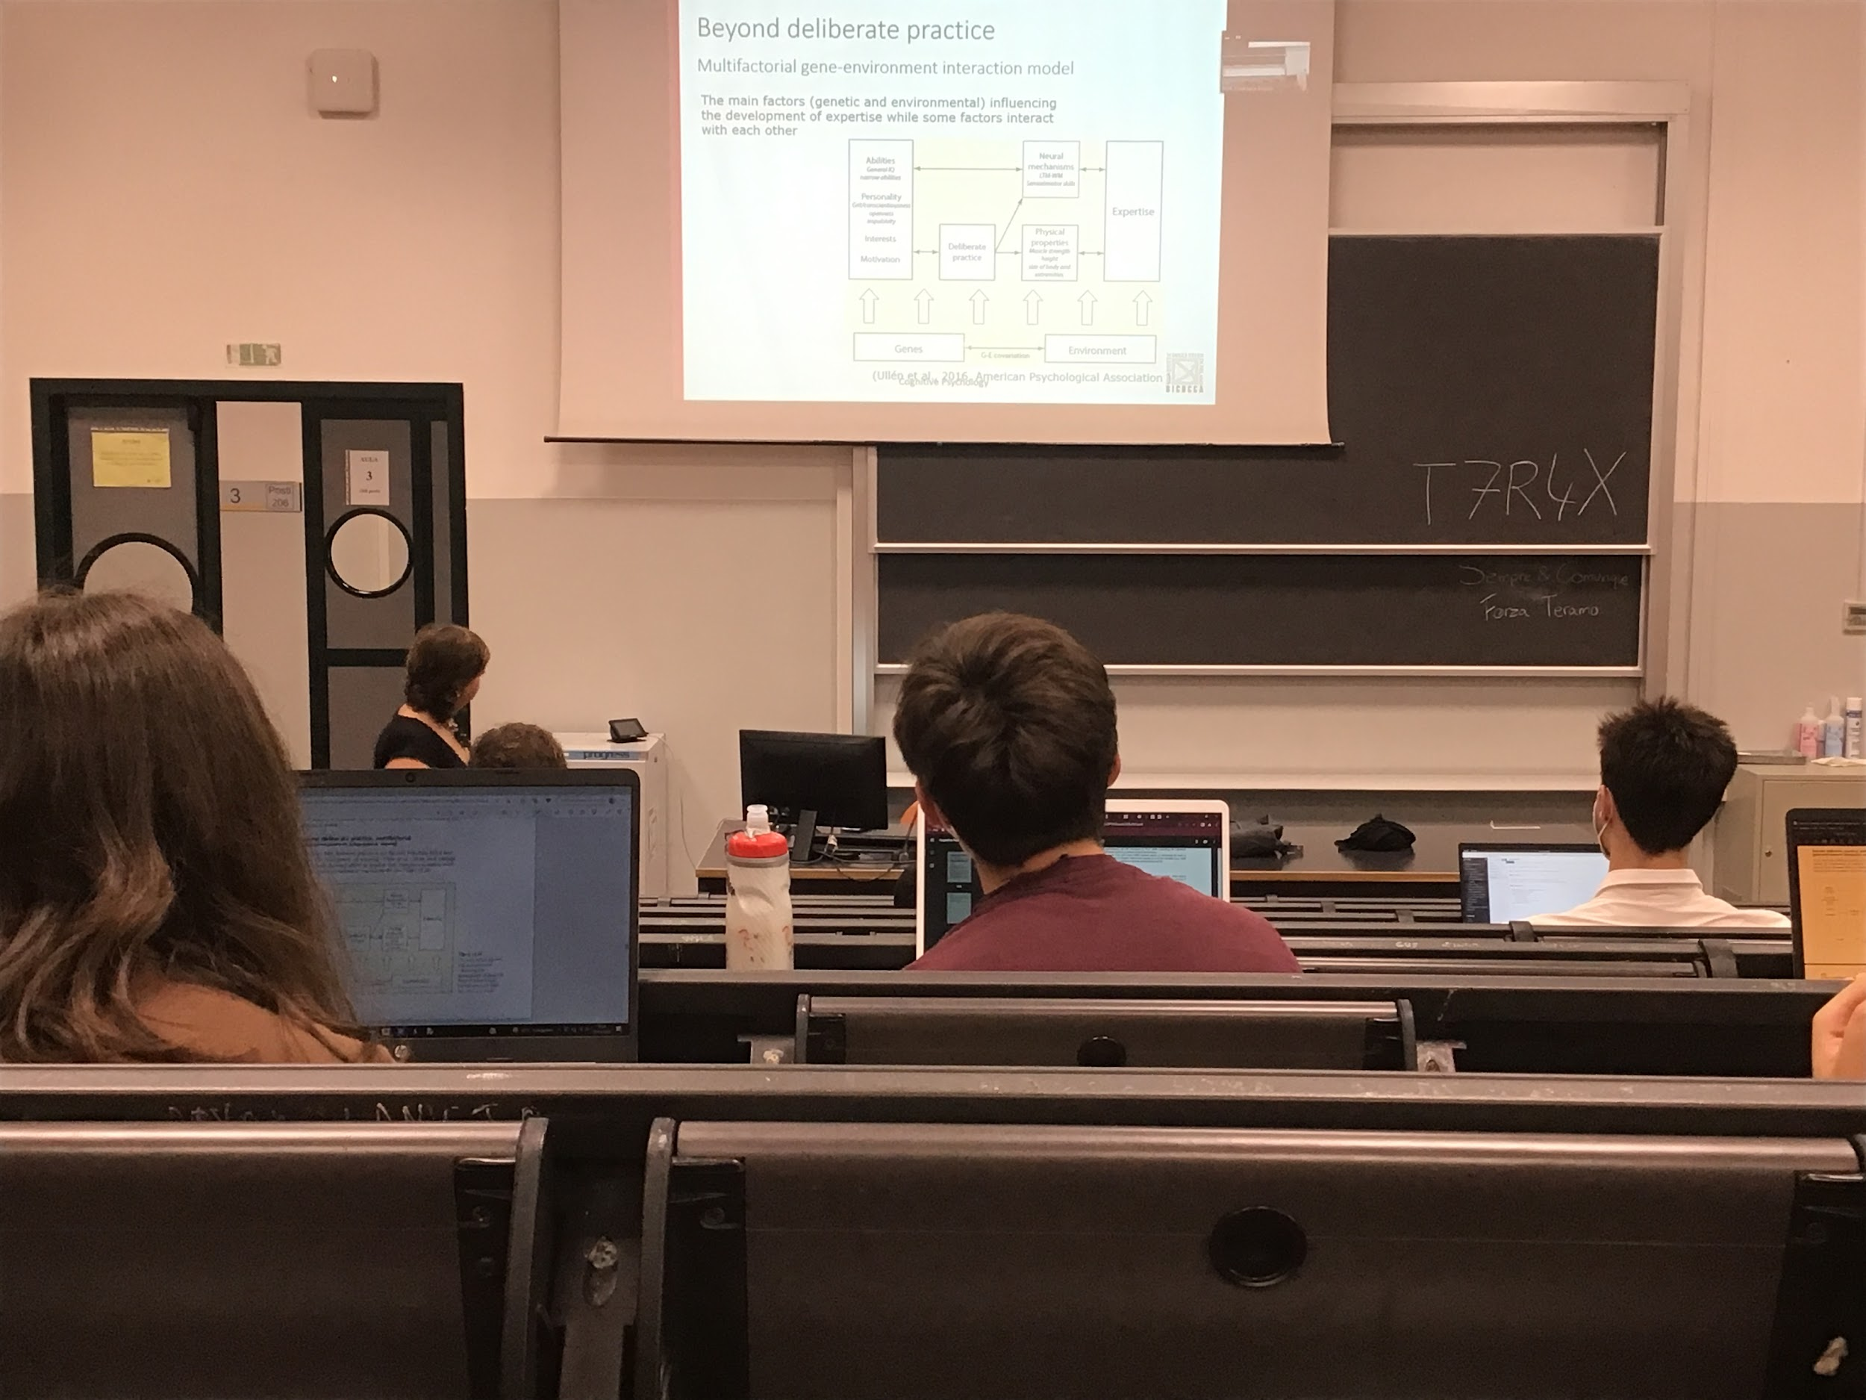

**We have to take in consideration no only the environment but also the genes to explain experiences**